Activity: Elements of the Earth and Sky
Story: We have crash-landed on the alien planet Boiler Thrace 150. Our only hope to make it back to planet Earth is to identify the correct fuel source for our spaceship’s flux capacitor and unscramble the message that will launch our spacecraft. We can’t leave until every group has correctly identified the fuel source, received their correct launch code, and unscrambled the codes to reveal the hidden message. Determine this message before time expires by solving the puzzles. Good luck!

Additional Supplies:
- Periodic Table and Practice Isotope Math worksheet
- Pencils
- Project a countdown timer once they begin the word search
- Laptop ready with Google Form to enter fuel source information
Lock Type | Lock Combo | How will they know the combo? | Where will it lead?
3 number -  Boxes 1a AND 1b  (2 sets) | 749  (both sets) | Word search  (Puzzle #1) | Prime Elements Quest  (Puzzle #2 in Boxes 1a,b)
Letter lock - Box 2 | MLRNS | Prime Elements Quest  (Puzzle #2 from Box 1)  First 5 primes: 2, 3, 5, 7, 11 | Isotope Math  (Puzzle #3 in Box 2)
(2) 4 digit locks -  Box 3 | 2511 0186  1st 2nd | Isotope Math  (Puzzle #3 from Box 2) | Rock kits  (Activity #4 in Box 3)
4 digit lock - Box 4 | 7900 | ID rocks and calculate mass of each compound  (Activity #4 from Box 3) | Element Scavenger Hunt  (Puzzle #5 in Box 4)
(2) 5 Directionals - Box 5 | 1st: R,D,D,L,D  2nd: U,L,R,U,L | Element Scavenger Hunt  (Puzzle #5 from Box 4) | Prism Glasses and Activity #6  (Located in Box 5)
Activity #6 (Station): Spectral Tube and Poster
Activity #7 (Laptop): Enter element name: (neon), atomic number (10), and molecular weight (20.18) into the Google Form to receive the launch code specific to your group BEFORE time expires. Form link: https://goo.gl/forms/iNHSpLZQE8N53Fqx1

The Google Form is set for 10 different teams. Each team will enter the info about the fuel source and in return will receive a unique LAUNCH CODE. All 10 teams must combine their LAUNCH CODES to come up with the hidden message before time expires.

Hidden Message: 150 YEARS OF GIANT LEAPS IN SCIENCE BOILER UP !
Lecture Notes: Elements of the Earth and Sky
Explain an atom. The structure of the atom: nucleus (protons and neutrons) and electrons. An atom is the smallest piece of matter that still maintains the physical properties of a chemical element.

Hand out periodic tables to each student and project the same periodic table on the Smart Board. Explain that each box describes an element (most are naturally occurring). Discuss periods (recurring property trends among the elements) and groups (families of elements with the same properties). Have them label groups 1(alkali metals), 2(alkaline earth metals), 17(halogens) and 18(noble gases).

The number of protons corresponds with atomic number - this is how they are arranged on PT. Atoms get larger as they increase their number of protons. Generally speaking, atomic size increases as you move right to left and down the PT. This is because as you move across (Left to Right) the number of electrons also increases and condenses the shell a little more with each element. When you get to the noble gas in the row, the outer shell is totally filled and the entire atom shrinks down to become the smallest in that period.

Talk about mass number as the sum of protons + neutrons = mass number. Compared to the size of the protons and neutrons, the electrons do not have a significant mass. The atomic number is the number of protons. Subtract the number of protons from the mass number to find the number of neutrons. Project the Practice Isotope Math worksheet on the Smart Board and practice finding the number of neutrons in each of the following isotopes. Point out that an individual isotope’s mass will not necessarily match the atomic mass listed on the PT. The mass of the PT is an average of ALL the isotopes that exist.

- Berylium-13 Berylium has an atomic number of 4, so its nucleus contains 4 protons.
This isotope has a mass of 13. Mass 13 - 4 Protons = 9 Neutrons

- Sodium-25 Sodium has an atomic number of 11, so its nucleus contains 11 protons.
This isotope has a mass of 25. 25 - 11 = 14 Neutrons

- Carbon-14 Carbon has an atomic number of 6, so its nucleus contains 6 protons.
This isotope has a mass of 14. 14 - 6 = 8 Neutrons

- Phosphorus-36 Phosphorus has 15 protons. This isotope has a mass of 36.
36 - 15 = 21 Neutrons

- Potassium-43 Potassium has 19 protons. This isotope has a mass of 43.
43 - 19 = 24 Neutrons
Separate students into 10 groups and make sure each group knows their Group Number. Prepare to begin the Breakout Activity.

Puzzle #1

Wordsearch: Numbers that correspond with atomic numbers and lead to element’s name in the puzzle. Selection of elements’ names will show a number code when circled. (Answer 749)
Symbol | name | atomic number
Na | Sodium | 11
Mg | Magnesium | 12
K | Potassium | 19
Ca | Calcium | 20
Ti | Titanium | 22
Fe | Iron | 26
Al | Aluminum | 13
Si | Silicon | 14
O | Oxygen | 8
C | Carbon | 6

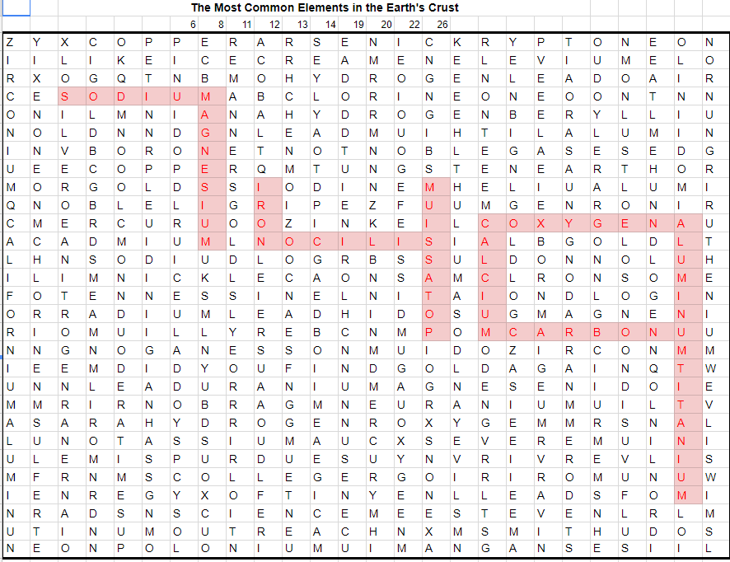

This code opens Box 1 (2 sets) which provides Puzzle #2.

Group #: _____
PRIME ELEMENTS QUEST
Puzzle #2

In the spaces below, record the names of the elements from the periodic table whose atomic numbers correspond with the first 5 prime numbers. Start the element name in the FIRST space provided. You may have extra spaces at the end.

Use the element names you have identified to determine the LETTER CODE you will need to open BOX #2. To get the code, write the boxed letters in order at the bottom of this page.

First: _____ _____ _____ _____ _____ _____ _____

Second: _____ _____ _____ _____ _____ _____ _____

Third: _____ _____ _____ _____ _____ _____ _____

Fourth: _____ _____ _____ _____ _____ _____ _____

Fifth: _____ _____ _____ _____ _____ _____ _____

The CODE to unlock Box #2: _____ _____ _____ _____ _____

V2

Group #: _____
PRIME ELEMENTS QUEST KEY
Puzzle #2

In the spaces below, record the names of the elements from the periodic table whose atomic numbers correspond with the first 5 prime numbers. Start the element name in the FIRST space provided. You may have extra spaces at the end.

Use the element names you have identified to determine the LETTER CODE you will need to open BOX #2. To get the code, write the boxed letters in order at the bottom of this page.

First: H E L I U M

Second: L I T H I U M

Third: B O R O N

Fourth: N I T R O G E N

Fifth: S O D I U M

The CODE to unlock Box #2: _____ _____ _____ _____ _____

Group #: _____

ISOTOPE MATH
Puzzle #3

Solve for the number of neutrons in each of the following isotopes, (just like we practiced!). If the answer is more than one digit, use the one’s place value.

Arrange the one’s place value for each answer at the bottom of the page to determine BOTH 4-digit CODES you will need to open BOX #3.

- Hydrogen-3 B) Aluminum-28 C) Gold-200

D) Sodium-22 E) Chlorine-37 F) Oxygen-19

G) Nitrogen-15 H) Radium-224

BOTH 4-digit CODES to unlock Box #3:

First: _____ _____ _____ _____ Second: _____ _____ _____ _____
A B C D E F G H
Group #: _____

ROCK KIT
Activity #4

Identify the Samples 5, 9, 15, and 18 from the rock/mineral kits by matching them to the correct name/chemical formula based on tested properties. Calculate the molecular mass of one molecule of each rock sample. Use the tenths place from each answer to determine the 4 digit code you will need to unlock Box #4.

Rock | Formula | Streak | Hardness | Color
Hematite | Fe²O³ | bright red to dark red | 5.5-6.5 | metallic gray, dull to bright red
Pyrite | FeS² | Greenish-black to brownish-black | 6-6.5 | Pale brass-yellow reflective; tarnishes darker and iridescent
Magnetite | Fe³O⁴ | black | 5.5-6.5 | Black, gray with brownish tint in reflected sun
Obsidian | SiO² | White | 5-5.5 | dark green/dark brown/ black
Calcite | CaCO³ | white | 3 | Usually white but also colorless, gray, red, green, blue, yellow, brown, orange
Fluorite | CaF² | white | 4 | Typically purple, green, and yellow. Also colorless, blue, red, and black
Quartz | SiO² | No streak | 7 | Colorless through various colors to black
Feldspar | KAlSi³O⁸ | white | 6-6.5 | pink/red hues // white/gray
Gold | Au | golden-yellow | 2.5-3.0 | yellow-orange

Rock kit Key:

 |  | Look at rock samples 5,9,10,15, 16, and 18. Calculate the atomic weight of each module and add them all up using 3 significant figures.
 |  | Rock | Formula | Streak | Hardness | Color
5 | 159.687 | Hematite | Fe2O3 | bright red to dark red | 5.5-6.5 | metallic gray, dull to bright red
9 | 119.965 | Pyrite | FeS2 | Greenish-black to brownish-black | 6-6.5 | Pale brass-yellow reflective; tarnishes darker and iridescent
10 |  | Magnetite | Fe3O4 | black | 5.5-6.5 | Black, gray with brownish tint in reflected sun
15 |  | Obsidian | SiO2 | White | 5-5.5 | dark green/dark brown/ black
16 | 100.086 | Calcite | CaCO3 | white | 3 | Usually white but also colorless, gray, red, green, blue, yellow, brown, orange
18 | 78.074 | Fluorite | CaF2 | white | 4 | Typically purple, green, and yellow. Also colorless, blue, red, and black
 |  | Quartz | SiO2 | No streak | 7 | Colorless through various colors to black
 |  | Feldspar | KAlSi3O8 | white | 6-6.5 | pink/red hues // white/gray
 |  | Gold | Au | golden-yellow | 2.5-3.0 | yellow-orange

Group #: _____
ELEMENT SCAVENGER HUNT
Puzzle #5
START at the SMALLEST element on the Periodic Table.

Which direction would you travel to get to the FIRST Noble gas? __________

From here, which direction would you travel to find an element with 10 protons? __________

Travel to the THIRD smallest alkali metal.

Would you travel UP or DOWN to get to the LARGEST alkaline earth metal? __________

Travel to an element that contains 15 protons.

Keeping in the same period as the element with 15 protons,
which direction do the elements get slightly larger? __________

Travel to the SECOND smallest halogen.

Would you travel UP or DOWN to get to an element with 35 protons? __________

Travel to the SECOND largest alkali metal.

Would you travel UP or DOWN to get to an element with 19 protons? __________

Travel to an element with a mass of 59 and a total of 31 neutrons.

From here, which direction would you travel to get to an element with a
mass of 64 and a total of 37 neutrons? __________

From here, which direction would you travel to get to an element with a
mass of 56 and a total of 27 neutrons? __________

Travel to the THIRD largest Noble gas.

Would you travel UP or DOWN to get to an element with 36 protons? __________

From the element with 36 protons, would you travel STRAIGHT UP or
LEFT and up to get back to the SMALLEST element on the Periodic Table? UP or LEFT
^{CIRCLE ONE}
Use these directions to unlock Box #5.
Group #: _____
FUEL SOURCE INFORMATION SHEET
Activity #6
Based on the line spectra from the poster, we have identified the fuel source as:

Element Name: _______________ Atomic #: __________ Atomic Mass: __________

Using the provided laptop, select your group’s number and enter the fuel source data.

When prompted, record your group’s unique LAUNCH CODE: __________________________

In the space below (and on the back if needed), make note of the other groups’ LAUNCH CODES. Work together with your group to unscramble the LAUNCH CODES to solve the hidden message before time runs out!

HIDDEN MESSAGE:

***********************************************************************************************************
Group #: _____
FUEL SOURCE INFORMATION SHEET
Activity #6
Based on the line spectra from the poster, we have identified the fuel source as:

Element Name: _______________ Atomic #: __________ Atomic Mass: __________

Using the provided laptop, select your group’s number and enter the fuel source data.

When prompted, record your group’s unique LAUNCH CODE: __________________________

In the space below (and on the back if needed), make note of the other groups’ LAUNCH CODES. Work together with your group to unscramble the LAUNCH CODES to solve the hidden message before time runs out!

HIDDEN MESSAGE:

