Running head: Land-Use Change in the Local Environment

Teachers as Learners Examine Land-Use Change in the Local Environment Using Remote Sensing Imagery

Hope Klagges, Jon Harbor, Daniel Shepardson, Cheryl Bell, Jason Meyer, Willie Burgess, and Ted Leuenberger

Hope Klagges is a Graduate Student in the Department of Earth and Atmospheric Sciences, Purdue University, West Lafayette, IN 47907-1397. (765) 494-0754 klagges@purdue.edu.

Jon Harbor is a Professor of Environmental Geosciences in the Department of Earth and Atmospheric Sciences, Purdue University, West Lafayette, IN 47907-1397.

Daniel Shepardson is an Associate Professor of Science Education in the Department of Curriculum and Instruction, Purdue University, West Lafayette, IN 47907-1442.

Cheryl Bell is a science education doctoral student and graduate assistant in the Department of Curriculum and Instruction, Purdue University, West Lafayette, IN 47907-1442.

Jason Meyer is a graduate student in the Department of Forestry and Natural Resources at Purdue University, West Lafayette, IN 47907-1200.

Willie Burgess is the Outreach Coordinator in the Department of Earth and Atmospheric Sciences, Purdue University, West Lafayette, IN 47907-1397.

Ted Leuenberger teaches science at Benton Central Jr/Sr High School and is the first Master Teacher for ENVISION at Purdue University, West Lafayette, IN 47907-1442.

Submitted April 2001, Revised and submitted September 2001

Submitted to Journal of Geography

Acknowledgements: The authors would like to thank ENVISION participants for their hard work and enthusiasm while completing this activity. Special thanks are given to Dan Getman and Shilpam Pandey for contributing their expertise to the activity design. Finally, the authors thank two anonymous reviewers for their insight. ENVISION is supported by the National Science Foundation (Award number 9819439-ESI). The opinions, findings, and conclusions or recommendations expressed in this article are those of the authors and do not necessarily reflect the views of the National Science Foundation. This manuscript was completed while Harbor was supported by the New Zealand - United States Educational Foundation as a Fulbright Senior Scholar.

Teachers as Learners Examine Land-use Change in the Local Environment
Using Remote Sensing Imagery
Abstract
In environmental science education, learners are exposed to earth phenomena that occur across a wide range of spatial and temporal scales. However, it is challenging for learners to grasp the significance of spatial and temporal change because they have limited perspectives of the Earth. Within the scientific community, remotely sensed imagery is utilized for observing the Earth as a system. These same tools can be applied at all levels in environmental science education to help learners understand and visualize earth change. In this article, the experiences of teachers as learners are described as they conducted a temporal analysis of a local wetland using aerial photography in an inquiry-based activity.

Keywords: inquiry, k-12 education, professional development, aerial photography, land-use change.

Introduction: Science, Learning, and Perspective
In science education, learners are exposed to environmental phenomena that occur across a wide range of spatial and temporal scales. The Earth is a dynamic planet and it is important for learners to observe, analyze, and understand how it changes over different scales (NASA 1998). However, understanding these changes is difficult for learners because of the limitations created by perspective, which is only broadened through experience.
Perspective, or point of view, drives individuals’ interpretations of the experiences they encounter. Moreover, every experience helps broaden individuals’ perspectives and helps develop their abilities for interpretation. This cycle empowers individuals by allowing them to continually build upon their knowledge of the world through their experiences (Elkind 1975).
In science, the role of perspective is just as pivotal for understanding earth change. As a result, with technological advances in aeronautics, photography, and satellites, scientists have refined remote sensing techniques in order to enhance our perspectives of the Earth. Remote sensing, broadly defined as the process of observing and analyzing the Earth from a distance, typically includes aerial photography and imagery from satellites and enables scientists to study temporal and spatial earth changes from space (Nellis 1994; NASA 1998).
Such technological advances in science can be utilized in the classroom to develop learners’ perspectives for understanding earth changes (Kirman 1997). In particular, because some geographic information is only apparent when the world is viewed from a distance, remotely sensed imagery enables us to realistically visualize spatial patterns over large areas (Nellis 1994; Quattrochi and Goodchild 1997).

Remote Sensing Imagery in the Classroom
In the United States, aerial photographs have been collected regularly since the late 1930s and provide an excellent medium for demonstrating how the environment changes over time. While both aerial photographs and more recent satellite images have adequate resolution for learners to orient themselves spatially through the identification of specific landmarks, aerial photographs are more freely and readily available for use in the classroom. A recent aerial photograph and topographic map of almost every community in the U.S. can be acquired free from TerraServer (www.terraserver.microsoft.com). Past aerial photographs can often be acquired from organizations such as the county Soil and Water Conservation District, the United States Geological Survey (USGS), or the county or city engineer or surveyor.
Information and resources for applying remote sensing technology are widely available free of charge, and NASA promotes classroom-based research that uses satellite imagery or aerial photographs to explore changes in the earth over time (www.NSIP.net). In addition, information on resources, ranging from books and web sites to posters and maps, can be found through the NASA website. Given the wide availability of data, the challenge then is to find meaningful ways to encourage teachers to integrate these information sources into curricula.

Overview
ENVISION is an environmental science institute for middle level teachers, funded by the National Science Foundation, that aims to provide teachers with the content knowledge, skills and experiences they need to integrate inquiry based studies of local environments into their curriculum (www.eas.purdue.edu/geomorph/envision). Specifically, participants are encouraged to utilize activities designed by ENVISION staff and other participants in their classrooms. In the ENVISION program, teachers as learners examined environmental science content focused around three modules: Urban Environments, Rural Environments, and Watersheds. Emphasis is placed on the interactions between these modules including the impact of land-use change on watersheds. The sample activity described here combines the content area of land-use change with remote sensing technology, in order to help participants define and apply a new perspective on the topic in their classrooms. For this activity, teachers as learners examined temporal changes in the local environment by conducting both a qualitative and quantitative analysis of the aerial photo imagery. After the exercise, the participants assessed the methods used and the results of the analysis.
The structure of this activity illustrates one way of integrating technology and research and analysis skills into flexible, inquiry-based approaches to student-centered learning. It also illustrates how this type of activity provides natural opportunities to address a wide range of scientific issues, such as the development of classification schemes and the importance of accuracy and precision. Because these issues emerge as a natural part of the activity, an immediate context and motivation for discussing the issues is provided, heightening the significance of the learning opportunity to the student.

Sample Activity: Teachers as Learners Investigate Land-Use Change
The activity began with a whole group discussion of environmental issues currently affecting local communities. Through the use of guiding questions, the participants brainstormed ideas and came up with issues such as: pollution, water quality and quantity, population growth, urban sprawl, and land-use change. The instructor then asked the participants to focus on the issues of urban sprawl and land-use change that had been identified and to determine what information they would like to learn about urban sprawl in a particular study region. From this discussion, many important questions arose about the potential effects of urban sprawl (Table 1), and several were addressed throughout the rest of the activity. These included: what is the dominant type of growth, the direction of growth, the rate of growth, and the effect of growth on the environment?
Table 1: Sample Questions Asked by Participants about Urban Sprawl

How does urban development impact quality of life?
How is the being used?
Where does the community’s waste go?
What will be the source of drinking water?
Will there be habitat loss from the development?
Will there need to be rezoning?

The purpose of this introductory discussion was to allow the participants to develop their own rationale for the remaining aspects of the lesson. By considering the issues of importance in their own communities and deciding what questions to ask about those issues, the teachers as learners were taking ownership of their learning and the activity became relevant to their experiences.

Air Photo Interpretation
Aerial photographs were presented as a tool that could be used to answer some of the participants’ questions about urban sprawl. Because learner familiarity with the region represented by remotely sensed data improves learner understanding and ability to develop geographic analysis skills (Audet and Abegg 1996), the area surrounding a local wetland, where several of the ENVISION activities had been conducted, was chosen for the temporal analysis. By looking at aerial photos of this wetland, dating from 1939 to 1998, the participants were quickly able to identify broad changes in land-use due to urban development (Figure 1). This preliminary assessment helped re-orient the participants to the region around the wetland and prepared them for conducting a qualitative temporal analysis.
Figure 1: Some Observed Land-use Changes around the Local Wetland
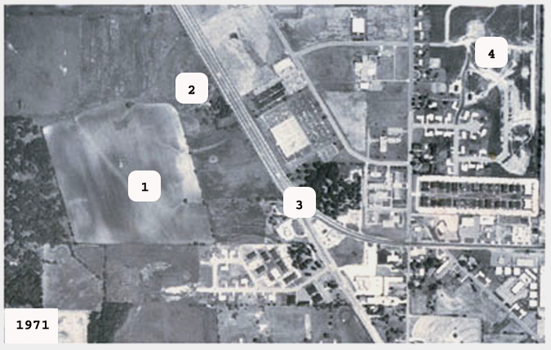
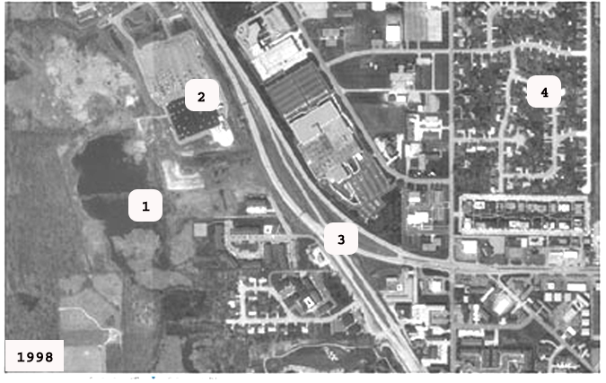
miles
½
0

1: Wetland (Celery Bog) | 2: Commercial Development
3: Highway Development | 4: Residential Development

Qualitative Analysis
Once the study region had been introduced, the participants were asked to analyze aerial photographs of the wetland taken in two different years and to describe the changes they observed. For the qualitative analysis, the participants listed observable changes and focused on aspects they felt were relevant to their previous questions about urban growth. They determined that the direction of growth was predominantly to the west, new roads had been constructed, and commercial, residential, and industrial growth was taking place near the wetland. Because the wetland had been recently designated as a natural area, the participants also discussed implications of urban sprawl on the health of the local wetland. It is important to note that the participants were easily able to identify key landmarks on the air photos, and were surprised and interested in the changes that they could identify in this familiar area. Thus, participants were developing a heightened awareness of the rate and scale of land-use change.
After conducting a qualitative analysis, the participants shared their observations in small groups and, then, with the whole group. During the discussion, in response to prompts such as “what else could we do with these images, and what additional information would you like to have?” the participants came up with the idea that a quantitative analysis of the observed changes would provide valuable information. Therefore, the list of observed changes recorded in the discussion was used to develop categories for the quantitative analysis, or land-use classification, which enabled the participants to answer questions such as, “what percentage of land area was used for farming in 1971versus 1998?”

Quantitative Analysis
For the quantitative analysis, the participants were divided into groups of four and each group was given an aerial photograph of the wetland from 1971 and 1998. Each photograph was divided into four sections, approximately 15cm x 25cm, and group members analyzed one quarter of each photograph. The analysis was conducted using a grid system consisting of transparent graph paper overlaid on the photo such that the grid represented the land area for one quarter of the image. Then, the participants outlined the pre-determined land-use categories on the grid. By counting the number of squares in each category and dividing by the total number of squares in the grid, representing the total land area, the participants were able to determine the percentage of land-use for each category.
In order for the analysis to be meaningful, or for comparisons to be made easily, a consistent classification system needed to be used. We could have allowed each participant to do things in her own way, and then allowed the group to discover later that they needed to go back and redo the work to overcome the problems involved in comparing results from different classification systems. However, given limited time, we opted to structure the activity so that all groups developed a single classification system. This system included categories of land-use to be identified and color codes for each category. Using the list of changes identified from the qualitative analysis, the participants were asked to list and define the land-uses they wanted to quantify. The task seemed simple at first, but quickly escalated into questions on how to interpret the fine distinctions between categories. For example, are apartment complexes classified as residential or commercial, does green space refer to open fields or just trees in an urban area? The group did eventually agree on a classification system, but many questions on how to interpret the system remained (Table 2).
Table 2: Classification System Created by the Participants
Category | Description | Color
Agriculture | Farms
Natural | Forests; wetlands
Residential | Homes w/ lawns
Commercial | Buildings w/ parking lots; roads

Because communication is essential to the development of a representative classification system, uncertainty and questions were encouraged and directed toward group members throughout the analysis. One issue that surfaced during the analysis was how to classify land-uses that did not fill an entire grid cell, that is, the establishment of a minimum area of significance. Discussions on these issues were encouraged within each group, but were intentionally limited between groups so that the different approaches and interpretations of the classification system could be shared at the conclusion of the activity (Scheurman 1998).
When analysis of each quarter was completed, the results were combined for the entire photograph and discrepancies, such as land-use classifications that did not line up across the photo boundaries, were identified (Figure 2). Discussion among group members led to several explanations for the misclassification, which included not knowing how to interpret a region at the edge of a photograph where less information was available and not establishing a minimum area of significance. For example, some participants outlined individual objects in the classification, such as roads, while others outlined each grid cell based on the land-use category that filled a majority of the cell (Figure 3).

Figure 2: An Example Classification of the Area Surrounding the Wetland
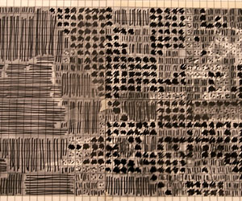 |  | 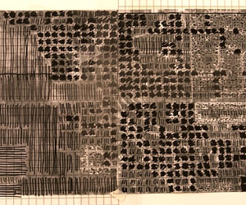
1971 |  | 1998
Agriculture |  | Residential
Natural |  | Commercial
Note: This classification was completed for demonstration purposes in this paper because the color classifications created by ENVISION participants were difficult to see in black and white.

Figure 3: Comparison of Participant Classification Strategies
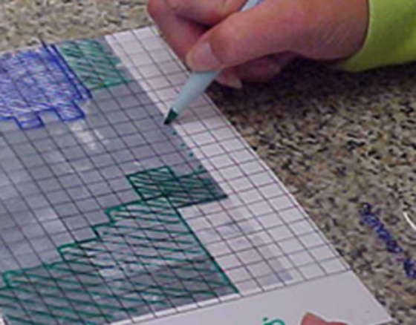 | 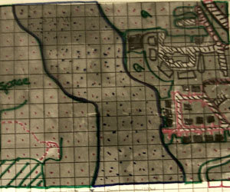
A participant classifying the image by determining the land-use comprising the majority of each grid cell. | A participant classifying the image by outlining specific buildings, roads, and land uses within each grid cell.

After compiling the photographs for each year, comparisons were made by considering the following questions: what percentage of land is found in each category and what is the percent change for each land-use (Table 3)?

Table 3: Comparison of Land-Use Percentages and Changes
Determined by two Different Groups
 | Group 1 |  |  | Group 2
 | 1971 (%) | 1998 (%) | % Change* | 1971 (%) | 1998 (%) | % Change*
Agriculture | 38 | 0 | -100 | 18 | 2 | -89
Natural | 13 | 42 | 223 | 47 | 43 | -9
Residential | 19 | 18 | -5 | 19 | 5 | -74
Commercial | 30 | 40 | 33 | 14 | 51 | 264
* % Change is the difference between the 1971 and 1998 values expressed as a percent of the 1971 value

Data Interpretation and Analysis
Issues such as accuracy, precision, and effectiveness of the classification system arose naturally as a component of the discussion surrounding group presentations on results. Because each group had analyzed the same two photographs, comparing the percentages of land-use and land-use change between the groups provided a measure of the accuracy and precision for the classification system. Each group presented the results of their quantitative analysis by explaining how they interpreted the classification system and addressing problems they encountered during the analysis. During the presentations, it was obvious that small differences in interpretation could lead to significant differences in the classification. For example, in the 1971 photograph, there was a region that had been bulldozed, but construction had not begun. Each group applied the classification system differently to this region; some considered the region commercial because there would be buildings there and others considered the region natural because there were no buildings there yet. Therefore, the participants concluded that a more well-defined classification system was needed for a more accurate analysis, as well as more discussion between the groups. These conclusions have clear value in terms of understanding scientific inquiry and how a community of scientists might need to work together.
In order to evaluate the effectiveness of the analysis, the participants compared the quantitative data to the qualitative data and determined if their original questions had been answered by the analysis. At the beginning of the activity, the participants stated that they wanted to know the dominant types of growth, the direction of growth, the rate of growth, and the effect of growth on the environment. From the qualitative analysis, they had determined the direction of growth to be predominantly to the west, but could not explicitly state the dominant type of growth or the rate of growth. Through the quantitative analysis, Group 2 determined that commercial growth dominated the area, but Group 1 determined the natural land use to be dominant. The different interpretations of the bulldozed region in 1971 as either commercial or natural, in part, explain the discrepancy in the dominant land use. Both groups determined that agriculture suffered the greatest losses and was replaced, primarily, by natural land uses. This was the result of the wetland recovery between 1971 and 1998 when the tile drainage system began to fail and agriculture was abandoned at the wetland site. While both groups demonstrated that agriculture was replaced by natural land uses, their quantitative analyses did not demonstrate agreement for the percentage change in natural land use (Table 3). One possible explanation for these differences was the misclassification of agricultural land as natural in 1971. Most of the participants were not familiar with the area during that time and did not have first-hand experience to aid in the image interpretation. Finally, the analyses demonstrated that commercial development was expanding west toward the recovering wetland, and in turn, provided the participants with a platform from which they could develop further investigations into the impacts of urban sprawl to the environment.
In general, the quantitative analyses conducted by the groups were similar for the 1998 image and the greatest discrepancies were found in the classification of the 1971 image. As stated previously, unfamiliarity with the area in 1971 contributed to these differences. In addition, the 1971 image was of poorer quality than the 1998 image making image interpretation more difficult. These situations are representative of the experiences learners will encounter in the classroom, as they will be interpreting some poor quality images captured before they were born. With adequate time, learners can be encouraged to use reports from the local historical society and older citizens to minimize error in their classifications.
Pedagogically, this part of the activity was valuable because the participants working as scientists were involved in an ongoing discussion about ways to improve the accuracy and precision of classification systems (Summerby-Murray 2001). In addition, the participants gathered data to answer their own questions about urban sprawl and applied that data to better understand the impact of urban development on the environment.

Discussion and Conclusion
The main goal of this activity was to create an experience for teachers, which they could in turn apply in their classrooms to expand their students’ perspectives of spatial and temporal change. Studying changes to a local watershed over a twenty-seven year period and understanding the impacts of those changes is a challenge for learners who have not witnessed regional changes in their lifetime. Therefore, with the use of aerial photographs of a local area known to the students, learners are provided with a concrete, relevant model of land-use change. By observing urban sprawl from the aerial perspective, learners begin to visualize the trade off between types of land-use, as one type is lost to the growth of another. Moreover, they observe the impacts of growth on the environment with the loss of trees and riparian buffers, an increased coverage by impervious areas (roads, parking lots, and buildings), and even altered drainage patterns of rivers from road or dam construction. When learners are provided with a concrete representation of a concept and are able to experience the concept, it becomes relevant to their lives. With relevancy, projects and activities built upon the initial concept are more meaningful. For example, after analyzing the changes in land-use in their community, learners can test their predictions of the environmental impacts through water quality testing or develop plans for improving the environmental health of their community. In addition, building on the learners' new understanding of how to both view and utilize remotely sensed imagery, additional activities considering state, regional, or international changes in land-use, or other parameters, could be introduced.
A second type of relevancy for the activity is the degree to which it reflects authentic techniques and concerns in professional science (Keiper 1999). On February 21, 2000, a news release from MSNBC, entitled “NASA’s eyes show Earth’s sprawl”, asserted “…every satellite image tells a story. In the ones, released Monday by NASA, the stories about Earth are not pleasant ones” (Llanos 2000). The news release described research by NASA in which satellite imagery demonstrated the negative impacts of urban sprawl on the environment. Moreover, the release stated that NASA believes satellite imagery could help urban planners do a better job predicting growth, energy planners better understand energy use, and weather forecasters improve their predictions of thunderstorms. Therefore, the benefits of a new perspective on the Earth, achieved through improved technology, are being applied in many fields of science. By introducing learners to the aerial perspective now and encouraging them to analyze current geographic issues, they will be better prepared to make contributions to science in the future.
Finally, the activity described introduces learners' to important geographic concepts of spatial and temporal analysis through a low-tech approach. While studies indicate that complicated computer programs can be effectively applied in a constructivist classroom (Keiper 1999; Summerby-Murray 2001), student time is often dominated by learning the software and thus student development of spatial analysis skills is limited (Meyer et al. 1999; Audet and Abegg 1996). Therefore, in this activity, instead of manipulating software, learners' focus on how to classify an aerial photograph and, subsequently, how to quantify and analyze the classification. In addition, learners' actively participate in the temporal analysis and, such hands-on experiences create a realistic representation of spatial inquiry and problem-solving skills (Walsh 1992). Once learners have applied the skills for geographic analysis in a variety of hands-on activities then the integration of computer software into the curriculum is a logical next step for applying the skills learned to more complex data sets (Elkind 1975). Because the activity described was developed to introduce learners to a new perspective and geographic analysis skills that can be applied in investigations of their local environment, a low-tech, classroom friendly, and concept-focused activity was necessary to promote confidence and understanding.

References
Audet, R.H. and G.L. Abegg. 1996. Geographic Information Systems: Implications for Problem Solving. Journal of Research in Science Teaching 33(4): 21-45.

Elkind, D. 1975. Child Development and Education. New York: Oxford University Press.

Keiper, T.A. 1999. GIS for elementary students: An inquiry into a new approach for learning geography. Journal of Geography 98:47-59.

Kirman, J.M. 1997. A teacher’s introduction to remote sensing. Journal of Geography 96(3): 171-76.

Llanos, M. February 21, 2000. "NASA's eyes show Earth's sprawl." http://www.msnbc.com/news/372774.asp February 24, 2000.

Meyer, J.W., J. Butterick, M. Olkin, and G. Zack. 1999. GIS in the K-12 curriculum: A cautionary note. Professional Geographer 51(4): 571-578.

National Aeronautics and Space Administration (NASA) and NASA Student Involvement Program (NSIP). 1998. Watching Earth Change: Educators' Resource Guide. EP-1998-10-386-HQ. Available Online: http://www.NSIP.net

Nellis, D.M. 1994. Foreword. In Up Close From Afar: Using remote sensing to teach the American landscape, ed. P.R. Baumann. Pathways in Geography Series: Title No. 8. Indiana, PA: National Council for Geographic Education.

Quattrochi, D.A. and M.F. Goodchild. 1997. Scale, Multiscaling, Remote Sensing, and GIS. In Scale in Remote Sensing and GIS, eds. D.A. Quattrochi and M.F. Goodchild, pp. 1-11. New York: Lewis Publishers.

Scheurman, G. 1998. From behaviorist to constructivist teaching. Social Education 62(1):6-9.

Summerby-Murray, R. 2001. Analysing heritage landscapes with historical GIS: contributions from problem-based inquiry and constructivist pedagogy. Journal of Geography in Higher Education 25(1): 37-52.

TerraServer (2000). Available Online: http://www.terraserver.microsoft.com

Walsh, S.J. 1992. Spatial education and integrated hands-on training: Essential foundations of GIS instruction. Journal of Geography 91(2):54-61.

