ENVISION:
Learning Environmental Science and Learning to Teach through Inquiry

Daniel P. Shepardson¹, Jon Harbor², Cheryl Bell¹, Jason Meyer³,
Ted Leuenberger⁴ Hope Klagges², and Wilella Burgess²

Purdue University
West Lafayette, IN 47907-1442

¹Department of Curriculum and Instruction

²Department of Earth and Atmospheric Science

³Department of Forestry and Natural Resources
⁴Benton Central Community Schools

November 2000

ENVISION is supported by the National Science Foundation (Award number 9819439-ESI). The opinions, findings, and conclusions or recommendations expressed in this article are those of the authors and do not necessarily reflect the views of the National Science Foundation. This manuscript was completed while Harbor was supported by the New Zealand – United States Educational Foundation as a Fulbright Senior Scholar.

Running Head: ENVISION

ENVISION:
Learning Environmental Science and Learning to Teach through Inquiry

The National Science Education Standards (National Research Council [NRC], 1996) for professional development stress that an effective way for teachers to learn science is through inquiry, by conducting investigations of phenomena and issues and utilizing technology and scientific literature to enhance their scientific understandings. The ENVISION project, funded by the National Science Foundation (Award number 9819439-ESI), implements this professional development approach by engaging teachers in learning science through investigating local environmental issues, and at the same time model appropriate techniques for teaching children. A major component of ENVISION is a residential summer program during which teams of teachers design and conduct their own local environmental research. Thus, teachers learn science and learn to teach science as inquiry through inquiry. Through this process teachers as learners construct their own understanding of inquiry and what it means in their classroom. Teachers as scientists also construct knowledge, enhance their inquiry skills and abilities, gain confidence in designing and conducting investigations, use technologies and scientific equipment, and communicate ideas and findings.
This article explores how teachers engaged in inquiry and learned about inquiry teaching during the ENVISION summer institute and two pre-ENVISION pilot projects (NSF grant #9816809-OCE; Indiana Commission for Higher Education grant #98-10). We first review the theoretical basis of the project, and then describe the environmental research process teachers engaged in as “teachers as scientists”. To illustrate the process we share excerpts of teacher work and products. We conclude the article by summarizing how this process aligns with the NRC inquiry and professional development standards.
Theoretical Basis
The ENVISION project is built upon constructivist (Piaget, 1970) and social constructivist (Vygotsky, 1986) principles of learning: that individuals make sense of the world through their own constructions that are based on their prior understandings and experiences and through socio-cultural interactions. For participating teachers this means that they constructed or re-constructed their understandings about science concepts and inquiry based on their experiences in “doing” science as a member of a scientific community. Social constructivism emphasizes learning science by experiencing science--acting, thinking, seeing, and talking within the community or culture of science (Shepardson, 1999). Thus, the intended outcome of ENVISION’s approach is that teachers experiencing science through inquiry will in turn teach science to their students by engaging them in inquiry-based investigations. These teachers will require students to design, plan, and complete scientific investigations, including communication of their understandings and findings through authentic products and processes, such as PowerPoint presentations and written scientific reports.
Learning Science Through Investigating the Environment
The ENVISION project involves teachers in planning and conducting their own environmental investigations. This provides teachers (students) with the opportunity to plan and control their own educational experiences. Pedagogically, this process allows learners to generate their own research questions, create their own procedures for collecting evidence, and use data as the basis for their explanations (NRC, 2000). By designing and conducting their own environmental research project, teachers learn science in a meaningful context, apply scientific knowledge to local problems and issues, develop problem-solving skills and abilities, utilize resources within and around the school, and link classroom science to real world issues and problems (Stapp, Wols, & Staukoub, 1996). In this section we describe how teachers participating in the ENVISION project planned and conducted their own environmental research: how teachers conducted a site survey, designed and conducted their study, presented their results, and used technology.
Getting Started: The Site Survey. In the ENVISION project teachers initiate their local environmental field studies or investigations by conducting an environmental site survey. Rather than immediately designing a research project, the participants start by collecting background information about a local area. The goal of this step is to develop an understanding of the conditions and context of the site, so that research projects focus on major issues and conditions at the site itself. For many teachers and students, the hardest part of research is coming up with a project idea. The site survey provides a way to explore the site in such a way that possible research topics are easier to see. Rather than starting with a preconceived idea about what research will be done, the site survey provides a chance to see what research opportunities the site offers. The outcome is research that is suited to the site, is of local significance, and is relatively easy to carry out.
The site survey begins by using Internet resources. The TerraServer web site (http://terraserver.microsoft.com/) is used to display aerial photographs and topographic maps of the site, providing an overview of current and historical land use patterns and landforms. Review of aerial photographs may also provide insight and clues to environmental problems to be investigated and familiarizes the investigator with the environment and may define the physical boundaries for the investigation. For example, an analysis of the Celery Bog aerial photograph from TerraServer (Figure 1) shows that the wetland is surrounded by a golf course, housing subdivision, an apartment complex, and agricultural lands. Teachers and students recognize that these land uses may have an impact on the wetland environment, presenting possible lines of thinking that can lead to specific research investigations. Seeing a golf course and agricultural land next to a wetland might suggest a possible impact on the wetland from pesticides and fertilizers in storm water runoff. This in turn leads to the idea of measuring surface water runoff from the golf course and agricultural area, monitoring the water for pesticides and fertilizers. Analysis of the aerial photograph and topographic map also provides insight into where monitoring or data collection sites might be established.

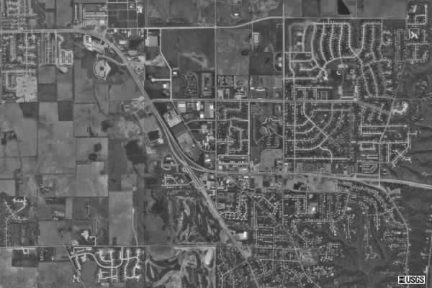
Figure 1. TerraServer Image of Celery Bog
The second step in the site assessment is to conduct an on-site survey. The on-site survey is a visual assessment of the environment. Teachers participating in ENVISION use site surveys developed by the Environmental Protection Agency (EPA) for streams/watersheds and wetlands, and ENVISION-developed site surveys for school yards and urban and built environments. The visual survey provides a closer look at the environmental conditions and potential environmental impacts within the area selected for investigation, allowing for more specific investigation of the environment and for opportunities to develop a sense of what is at the site, and what potential research might be done. For example, the EPA (1997) visual assessment for steams/watersheds involves noting residential, commercial, industrial, recreational, and agricultural land use patterns within the watershed and surrounding stream, as well as other activities that may impact stream quality. After the visual survey has been completed, teachers generate research questions and then design and conduct a field investigation.
An excerpt from a teacher’s local watershed survey illustrates the types of observations teachers make, and in this case identifies the potential water drainage sources and potential sources of contaminants for a school pond that could be subjects for research:
The pond is enclosed in 6’ chain link fence, incorporating about 1 acre of land. The football field, buildings, parking lots, practice fields, and tennis courts all drain into the pond through a system of pipes with catch basins. The outlet of these pipes is a 12” concrete pipe that dumps into a 62’ shallow channel leading to the pond. The pond has a clay dam along the west-side, separating it from the highway. A ditch runs between the dam and the highway with a catch basin to collect pond overflow or dam leaks. The catch basin leads to a pipe traveling under the highway into farm drainage systems leading to the Vinnedge Lateral of the Stalk/Heston Ditch, which leads to the Yellow River.

As part of the watershed survey the teacher included photographs of the pond (Figure 2) and drainage pipe (Figure 3). By understanding the local watershed, potential water quality research projects were identified. Without the site survey it is often difficult for teachers and students to conceive of possible, relevant, and practical projects, thus the site survey step is an important part of the inquiry process.
In another example, teachers conducting a site survey of a local stream discovered that an electric utility company had stock-piled coal near the stream, suggesting the possibility that coal runoff during storm events would impact the water quality of the stream. Their research project did indeed show that during major storm events coal runoff entered the stream, as documented by their photograph (Figure 4) and water quality data.

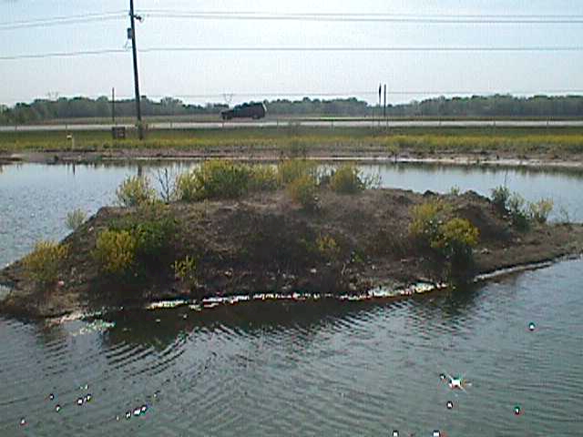
Figure 2. Teacher Photographs of School Pond

Figure 3. Teacher Photographs of Drainage Pipe
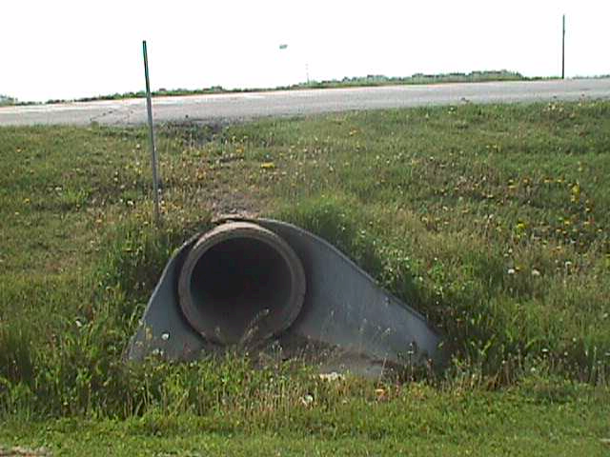
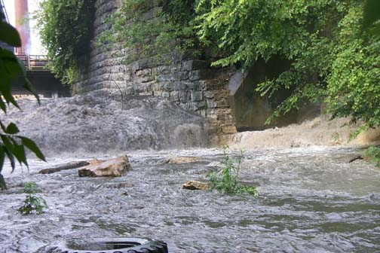
Figure 4. Coal Runoff

A third teacher example illustrates the importance of creating a site map (Figure 5). The site map provides insights into land use patterns surrounding the environmental site and potential environmental impacts or conditions that might be investigated. The site map also provides others with an overview of the local environment.

Figure 5. Teacher Created Site Map
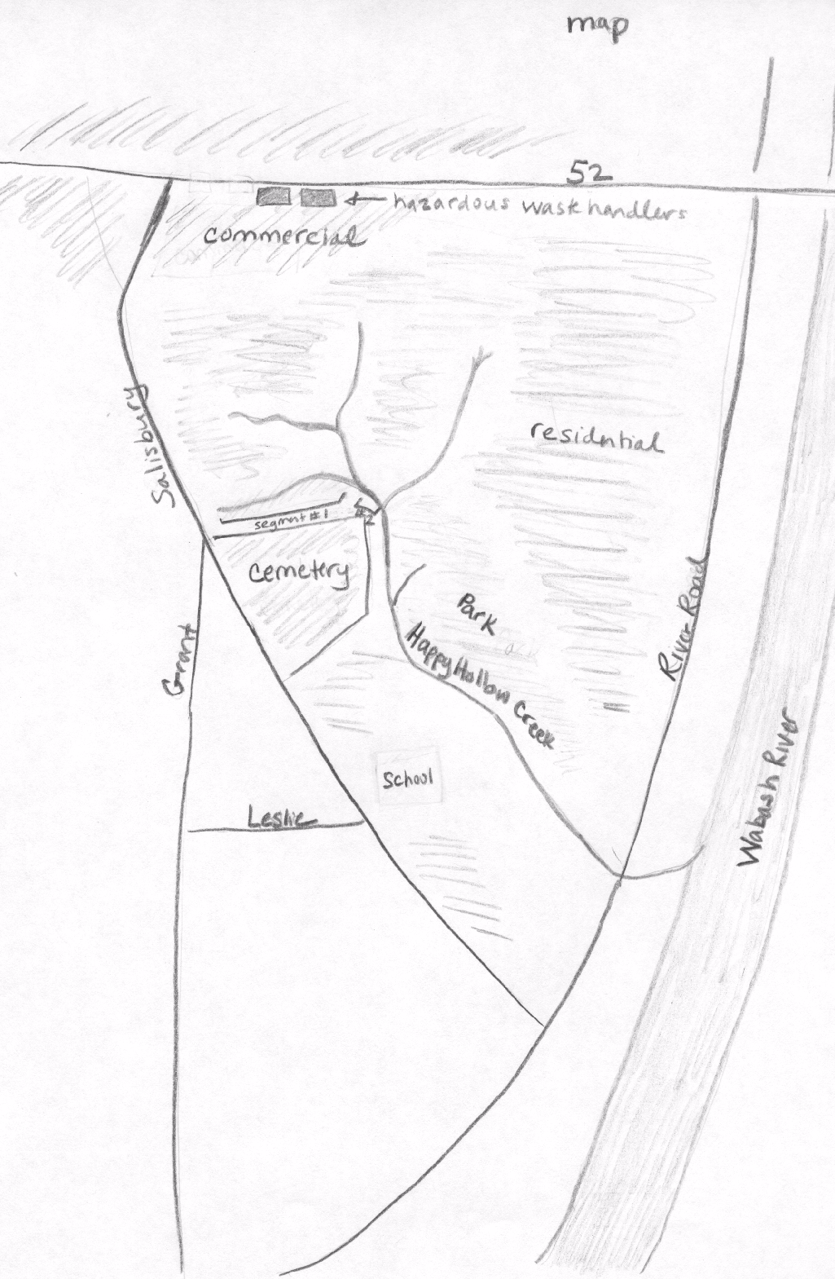
This process models appropriate pedagogy for beginning the inquiry. It enables learners to explore and share their ideas, understandings, and thinking about the environment. The teacher learns about the students’ understandings and interests by observing and listening to students as they complete the site surveys. The structure of the site survey guides the inquiry toward the big ideas or themes of science as opposed to more routine factual knowledge and memorization.
Designing the Study: The Proposal. In ENVISION teachers work in self-selected small group research teams. Each team formulates its own research ideas based on the knowledge, interests, skills and opinions of the team members. Before each team starts their investigation they write a short proposal clearly stating the procedures they intend to follow, the equipment they will use, and the techniques they will employ. The proposal also includes their current understandings of the problem and guiding questions that are motivating the study. Teachers are asked to write their proposal for a specific audience that they identify. The audience must be a potential real world user of the results of the research. For example, the audience could be a local city council, a citizens group, or a commercial client. This step encourages the teachers to focus on why the research question is important in terms of local, real-world interests. This heightens the sense of importance of the work, and helps develop an understanding of the practical uses of scientific research. The teachers are also made aware that this activity is identical to one used in the preparation of science undergraduate and graduate students for careers in basic and applied science (Harbor, 2000). This further reinforces the teachers’ sense that they are truly experiencing science as scientists.
The project proposals are critiqued by both ENVISION staff and other participating teachers. The critiques provide new insights into designing and conducting the investigation, and thus the proposal and research project evolves up to the moment of implementation. By critiquing their peers’ work, the teachers also get a better idea of how others are approaching doing and presenting their projects, and encourages the entire group to interact as a community of teacher-scientists.
Conducting the Investigation. Once each team has adjusted its research plan based on comments from peers and ENVISION staff, the teams conduct their field studies investigating the environment. This field study not only engages teachers in inquiry, but links science more closely to their lives and the environment they occupy. In almost all cases the teams choose projects that address environmental issues that are important both in the ENVISION study area and in areas surrounding their own schools. This addresses the issue that students are often disinterested in school science because it is not useful or relevant to the real world, their lives (Howe, 1991). Several examples of teacher-scientist team research projects are presented in Table 1.

Table 1. Examples of Teacher-Scientist Research Projects

Water quality of urban ponds. This project investigated the water quality of urban ponds used for water retention purposes.

The impact of Wal Mart on a local wetland. The project investigated the quality of water flowing into and out of a constructed wetland used to filter parking lot runoff.

Recreational water use. This project investigated the relationship between individuals' knowledge of water borne health hazards and there decisions to swim in different types of recreational waters (e.g., swimming pools, rivers, and lakes).

Edible and medicinal plants of the watershed. The project involved a vegetative field survey of a local wetland identifying the location of edible and medicinal plants in the wetland.

Water quality study of the Wabash River. This project investigated water quality at seven sites along the Wabash River, comparing water quality data to land use patterns.

An excerpt from a team’s final project report illustrates the authenticity of the environmental projects, investigating the potential septic system impact on stream quality in the town of Reynolds, and the use of TerraServer to obtain a topographical image of the lagoon type septic system and surrounding topography (Figure 6):

The town board of Reynolds, Indiana recently had several residents of the small community attend their monthly board meeting with a concern. They had read an article in the Journal and Courier about possible contamination caused by septic systems. Some of the residents realized that their town has an outdated lagoon type septic system which they believed could be contributing to contamination of surface water.

The teacher-scientist report continues, displaying their chemical data in a bar graph created using Microsoft Excel.

Figure 6. TerraServer Topographical Image of Reynolds Lagoon Septic System

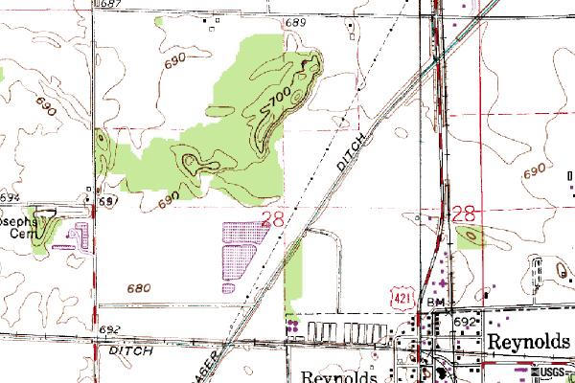

As the teachers progress in collecting field data, they organize and analyze these data, drawing interpretations about the patterns they observe. The field work experience gives meaning to what it means to “do” science, as well as to the science ideas used to make sense of the world. As the groups begin to interpret and analyze their results, scientific resources are utilized to assist in constructing explanations of the data, including group members, peers in other teams, and project and university scientists. Thus the teachers participate in brainstorming and discussion to interpret their data, an integral part of most scientific research projects. As analysis proceeds, new questions are often generated and additional data collection is conducted.
Presenting the Results. To complete the research project, each team prepares a brief written report and a PowerPoint presentation to communicate procedures, findings, and ideas to the specific audience the group identified as its target, as well as to the ENVISION community. Both of these products summarize the context of the work, goals, hypotheses, procedures, data collected, and interpretation and conclusions. The PowerPoint presentation is given as a formal presentation to the ENVISION staff and other participants, who then question the group about the work. Thus, the research process is not conducted in isolation of others, but as a team and as a member of a community of teacher scientists.
Using Technology in Research and Presentation. Many of the teachers participating in ENVISION have limited backgrounds in using computer technology—PowerPoint, Excel, the Internet—or how computer technology could be integrated into scientific investigations. Using technology to conduct and report on their investigations teachers gain pedagogical knowledge about integrating technology into their classrooms.
PowerPoint excerpts (Figures 7 and 8) from a teacher-scientist team illustrate the use of technology not only to communicate ideas and findings, but as a means for documenting activity and environmental conditions through the lens of a digital camera. This research team was investigating the water quality of Indian Creek, selecting three sites and monitoring water quality upstream and downstream from these sites. The PowerPoint slide excerpts show the turbidity data (Figure 7) and coliform data (Figure 8). The team’s recommendations, as presented on their final slide, were:
- The presence of E. coli, higher levels of pH, and turbidity indicate the need for further testing in these areas.
- The stream does not appear to pose any immediate health risks, but more precise Coliform tests are needed to assure community health.

Figure 7. Teacher Created PowerPoint Slide Showing Turbidity Data
- Turbidity JTU’s (Jackson Turbidity Units)
0 JTU = 4 (Excellent) >40-100 = 2 (Fair)
0 - 40 = 3 (Good) > 100 = 1 (Poor)

Figure 8. Teacher Created PowerPoint Slide Showing Coliform Test

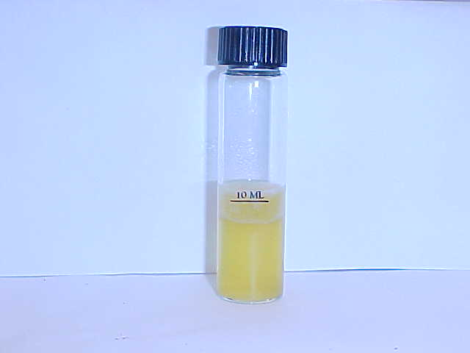
- Coliform = All six sites tested positive for the presence of E. coli
- A positive test indicates more than 200 total colonies per 100ml of water.

These recommendations show that the team members understand the limitation of the coliform test in terms of its precision, and the need to conduct more sensitive analyses as the next step in the research process. The teacher-scientists used a test that only indicates the presence or absence of fecal coliform, that includes E. coli, and recognize that a more selective test is needed to determine the type of fecal coliform and the number of colonies. The authenticity of the teacher-scientists study and the validity of their analysis and recommendations are confirmed by a side-bar statement that later appeared on the front page of the local newspaper (Journal and Courier, 2000, p. A1):
Progress and pollution. E. coli levels in Indian Creek have raised concerns in Wabash Township, particularly because a ban against sewer hookups to American Suburban Utilities Inc. has been lifted. With two new housing developments nearing approval, the balance between the environment and progress is being tested.

Teachers as Scientists and Professional Development
The ENVISION program involves teachers as scientists in investigating the environment. Through this process, teachers experience instruction that promotes inquiry. Investigation of questions, investigations extended over time, learning science processes in the context of the investigation, using manipulative, cognitive and procedural skills, using evidence to support explanations, and communicating explanations to the community (NRC, 1996). Further, the “teacher as scientist” process models the integration of inquiry into teaching and learning and the integration of science with teaching knowledge through collegial and collaborative learning. This process addresses “the need for teachers to do inquiry to learn its meaning, its value, and how to use it to help students learn . . . [and] the importance of a community of teacher-learners that mirrors scientific communities ” (NRC, 2000, p. 91).
By mapping the teachers’ activity on to the essential features of classroom inquiry (NRC, 2000), we can determine the degree that the professional development experience models appropriate classroom inquiry (Table 2). The teachers functioned at the top level of inquiry on three of the five elements: learner poses question, learner determines what constitutes evidence and collects it, and learner formulates explanation. Because ENVISION staff guided teachers in obtaining resources and information for explaining their data and required a written report and PowerPoint presentation, teachers functioned at the third level of inquiry in terms of determining their own sources of scientific information and their means for communicating their study.

Table 2. The Essential Features of Inquiry and the ENVISION Experience.

Essential Feature  (NRC, 2000, p. 29) | ENVISION Inquiry Level/NRC Description  (Level 4 more inquiry, Level 1 less inquiry) | ENVISION Evidence  of Activity
Learner engages in scientifically oriented questions | Level 4. Learner poses a question | Teacher-scientists identify their own environmental issue to investigate and generate their own guiding research questions.
Learner gives priority to evidence in responding to questions | Level 4. Learner determines what constitutes evidence and collects it | Teacher-scientists determine what procedures, equipment, and techniques are necessary for collecting data to answer question.
Learner formulates explanations from evidence | Level 4. Learner formulates explanation after summarizing evidence | Teacher-scientists develop explanations based on data collected.
Learner connects explanations to scientific knowledge | Level 3. Learner directed toward areas and sources of scientific knowledge | Teacher-scientists are assisted by ENVISION staff in obtaining resources and sources of information for understanding and explaining their data.
Learner communicates and justifies explanations | Level 3. Learner coached in development of communication | Teacher-scientists are required to prepare a written report and PowerPoint presentation to communicate their investigation and findings.

The ENVISION process enhances teachers’ understandings through inquiry, providing teachers with opportunities to learn science and inquiry teaching, including:
- How both science subject matter and inquiry outcomes can be built into learning experiences.
- How a deeper understanding of scientific concepts can promote discussion and the formulation of productive questions.
- How essential features of classroom inquiry can be woven into learning experiences.
- What it feels like to learn this way, complete with frustrations and struggles.
- What roles and behaviors instructors can use that promote and support learning. (NRC, 2000, p. 101).

This process shapes participating teachers’ pedagogical content knowledge (Shulman, 1986) by integrating what they know about environmental science and inquiry with what they know about teaching science as inquiry. The ENVISION program emphasizes “doing” inquiry through environmental research which informs teachers about their own classroom practice, teaching environmental science as inquiry. Teachers take what they have learned and experienced about their environmental investigations and shape their classroom instruction to reflect their science experiences. This professional development process provides teachers with learning experiences different from the traditional college course or in-service workshop (NRC, 2000). For more information on or an application to apply to the ENVISION summer institute visit the project’s web site at http://www.eas.purdue.edu/geomorph/envision/ or contact the authors.

References

Environmental Protection Agency (1997). Volunteer stream monitoring: A methods manual (EPA 841-B-97-003). Washington, DC: EPA, Office of Water.

Harbor, J. (2000). A capstone course in environmental geosciences. Journal of Geoscience Education, 48, 617-23.

Howe, Q. (1991). Under running laughter: Notes from a renegade classroom. New York: Macmillan.

National Research Council (1996). National science education standards. Washington, DC: National Academy Press.

National Research Council (2000). Inquiry and the national science education standards: A guide for teaching and learning. Washington, DC: National Academy Press.

Piaget, J. (1970). Genetic epistemology. New York: Columbia Press.

Progress and pollution. (2000, September 30). Journal and Courier, p. A1.

Shepardson, D.P. (1999). Learning science in a first grade science activity: A Vygotskian perspective. Science Education, 83, 621-638.

Shulman, L.S. (1986). Those who understand: Knowledge growth in teaching. Educational researcher, 15(2), 4-14.

Stapp, W.B., Wols, A., & Staukoub, S.L. (1996). Environmental education for empowerment: Action research and community problem solving. Dubuque, IA: Kendall/Hunt Publishing Co.

Vygotsky, L.S. (1986). Thought and language. A. Kozulin (Ed.), Cambridge, MA: MIT Press.

