Urban and Built Environments

Pre/Post Assessment

Name Date

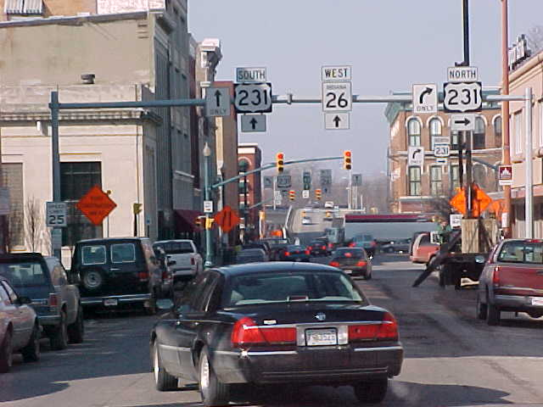

- Using the picture above, list some urban environmental science issues
that can be investigated.

- For one of the issues you identified, design an investigation of that issue.

