Jason M. Meyer

ENVISION

Purdue University

Table of Contents

Introduction . ……………………………………………………………3

Using EnviroMapper …………………………………………………….4

Environmental Profiles ………………………………………………14

Frequently Asked Questions…………………………………………16

Spring Workshop Introductory Lessons……………………………19

Introduction
EnviroMapper is an interactive online way that the public can access maps depicting environmental information, provided by the United States Environmental Protection Agency (EPA). This web-based resource allows users to query and view environmental data from the national level down to the community level (within one mile), and provides standard mapping functionality, including display, zoom, pan, and feature identification
(http://www.epa.gov/r02earth/gis/atlas/env_map.html). This tool provides users with interactive Geographic Information System (GIS) functionality using EPA geospatial data for the United States. This GIS functionality allows users to display multiple spatial layers at the same time. EnviroMapper maps several different types of environmental information, including drinking water, toxic and air releases, hazardous waste, waste discharge permits, and Superfund sites. EnviroMapper also links to text reports that provide additional information. If you have a web browser, you can use EnviroMapper (http://www.epa.gov/enviro/html/em/index.html).
EnviroMapper can be used to view and query EPA-regulated facility information stored in the Envirofacts Warehouse. It can also be used to environmental statistics, profiles, and trends; environmental information for U.S. metropolitan areas participating in the Environmental Monitoring for Public Access and Community Tracking (EMPACT) project; environmental information for watersheds; and Superfund National Priorities List (NPL) sites (http://www.epa.gov/enviro/html/em/index.html).
Users can create custom maps of any U.S. area, featuring types of environmental and geographic information they select. Maps can be manipulated by zooming in and out, panning to the side, and using the re-center function. State and county environmental profiles are also accessible to the public on EnviroMapper
(http://www.epa.gov/ceisweb1/ceishome/atlas/emhelp/help-what%20EM.html).

To locate EnviroMapper, enter this address into your internet browser’s location bar:
http://map3.epa.gov/enviromapper

Using EnviroMapper
This information can be found at: http://map3.epa.gov/enviromapper/help.html

When you first enter the EnviroMapper website, this is the first screen that you will see:

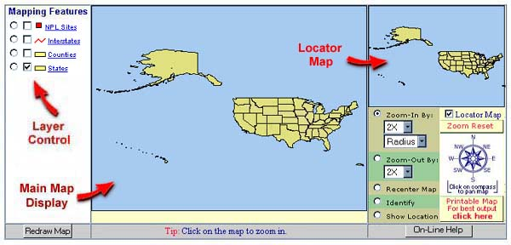
The Main Map Display shows the exact area you are interested in. The Locator Map covers the area seen in the Main Map Display with a red grid. In the above example, since the zoom is as far out as it will go, the Locator Map itself shows all that is being viewed. The Locator Map box can be turned on and off by checking or unchecking the box labeled “Locator Map” above the compass. Here is a screenshot of the Locator Map being used at the national scale level:

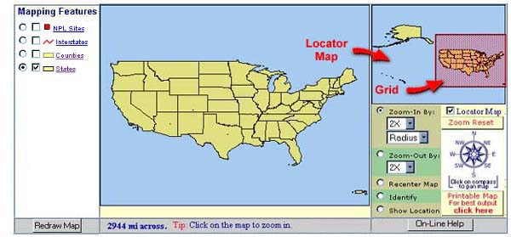

Here is an example of the Locator Map at the state level:

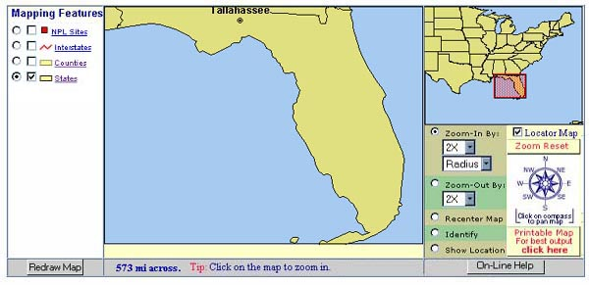

And here is an example of the Locator Map at a county level:

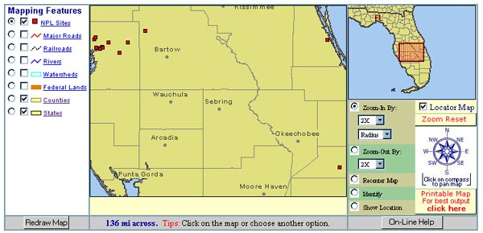

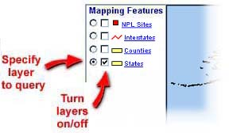
The layer control includes two types of buttons, with a set of buttons associated with each layer in the legend. The legend appears to the left of the main map display. Click on a toggle button (circle) to make your query selection. Only one toggle button can be selected at a time. Click on the checkbox (square) to make your layer selection for display. You may click on multiple checkboxes to select more than one layer, and you may de-select by clicking the checkbox again. Whenever a user modifies layer selections, the map needs to be re-drawn. This is done by clicking the “Redraw Map” button below the Map Features list.
Three different spatial scales are available on EnviroMapper: national, state, and county. Users may click on or off any layer available at a spatial scale. All layer names are hyperlinked – to see specific information (i.e., metadata) about that layer, simply click the link. The three spatial scales show different layers:
National
- National Priorities List (NPL) Sites
- Interstates
- County Boundary
- State Boundary
State
- NPL Sites
- Major Roads
- Railroads
- Rivers
- Watersheds (Hydrologic Catalog Units)
- Federal Lands
- County Boundaries
- State Boundaries
County
- NPL Sites
- Schools
- Hospitals
- Churches
- Populated Places
- Streets
- Streams
- Water Bodies
- ZIP Code Regions
- County Boundary

Here is an example of a map drawn at the county scale, looking at a Superfund Site and its related information:

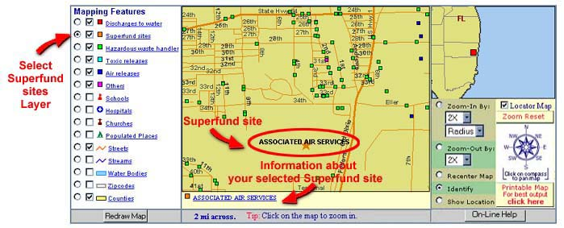

The Navigation Panel
The Navigation Panel, located to the right of the main map, contains a series of toggle circles and other buttons that allow the viewer to control the appearance of the map – zoom functions, re-center and identify, latitude/longitude, the locator map, the zoom reset button, the compass, and the printable map function.
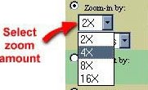
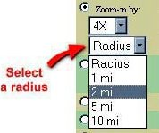
- Zoom in By: Click the Zoom in by toggle circle on the Navigation Panel. You can control the zoom in one of two ways. One way is by viewing the map 2, 4, 8, or 16 times closer than in the current display. The top drop down list allows you to select the zoom factor. The second way to zoom in is to view the map with a specific radius around a given point. For example you can pick a radius of 1, 2, 5, or 10 miles from any given point from the second drop down list. After selecting one of these two methods, click on the point on the map that you want as the center of the new map. EnviroMapper will then redraw your map.
- Zoom Out By: This function works in the same fashion as zooming in, only you must click the Zoom Out by toggle circle and use the zoom out drop down menus.

- Zoom in by Geography: The quickest way to select the area you want to view is to click on the “Zoom in by Geography” link at the top of the EnviroMapper homepage. The more specific an area you select, the more quickly you can reach the detail that you want. Specify a state, county, city, watershed, ZIP code, or EPA region. Below are the two menus from which to choose how you want to zoom in using geography (simply click on the EPA Region on the map to zoom to that region):
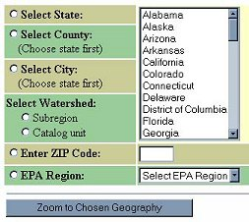
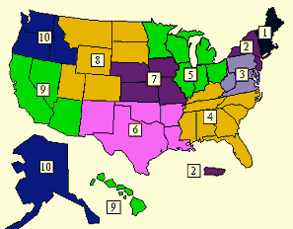

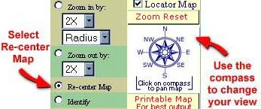
- Panning and Re-centering the Map: To change the view of your map by panning, click on the compass in the direction that you want to go. The map will shift (pan) in that direction. To re-center your map, click the “Re-center Map” toggle circle in the Navigation Panel. Then, click on the map where you want the new center to be. EnviroMapper will redraw the map.

- Identify: The “Identify” function requires several steps:
- Click on the “Identify” toggle circle in the Navigation Panel
- Click on the map layer of interest under Map Features
- Click on the specific feature on the map that you want identified.
- Once the feature is identified, you can click on the hyperlinked name of the feature below the main map to obtain a report on that feature.

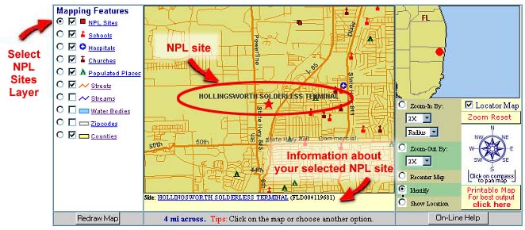

- Show Location: The “Show Location” toggle button allows the user to display the latitude and longitude for a specific point on the map. The latitude and longitude are featured in degrees/minutes/seconds and decimal degrees. To use this option, click on the “Show Location” toggle button. Then, click on a point/site of interest on the map. The map will regenerate with the selected site marked by a green cross. The latitude and longitude will appear under the main map display:
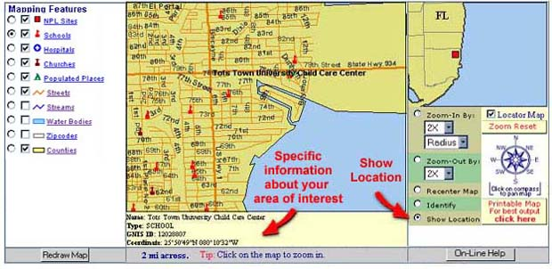
- Zoom Reset: The “Zoom Reset” option allows you to go back to the initial map of the United States (in essence, start over). The button that performs this function is located just above the compass in the Navigation Panel:
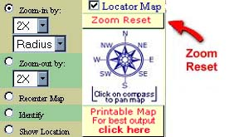

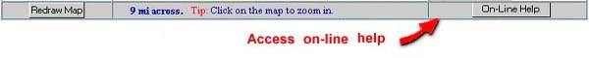
- On-Line Help: On-line help is always available for when my manual might fail you!

- Print Map: To print your map, select the “Printable Map” option from the EnviroMapper Navigation Panel:
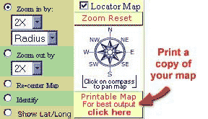

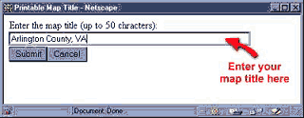
You will be presented with a window that allows you to create a title for your map. Enter the title that you have selected (up to 50 characters) and click on the “Submit” button:

After you have submitted the title for your map, the map to be printed will be displayed on the screen

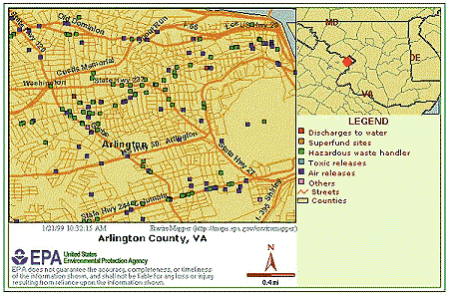
After you have submitted a title for your map, it will be displayed on the screen:

Next, if you are using Netscape Communicator 4.0 or greater, you will be presented with a print window that will allow you to specify any printer options you may want to use. You can change printer selection, properties, specify a print range for your map, and specify the number of copies you want to print. Once you are sure that everything is correct, select the “OK” button:
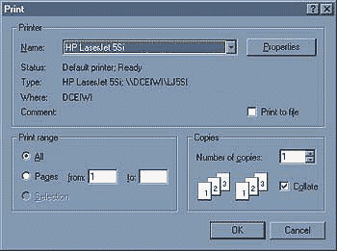

If you are using Internet Explorer or another browser, the following window will be displayed. Select the “OK” button to continue printing your map:

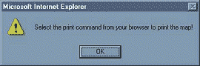

Environmental Profiles
Note: At the time this manual was written, this option was not available. Perhaps this section will be of use in the future.
This material was obtained at: http://www.epa.gov/ceisweb1/ceishome/atlas/emhelp/help-EnvProfile.html

An environmental profile is a summary of a particular environmental characteristic of a special area at a specific time (i.e., air quality in Lafayette, IN during 1988). The summary information is presented in graph and table form. The profile also includes background information on the environmental characteristic and the data source for the profile.
The environmental profile maps provide an opportunity to compare environmental characteristics for different areas in a single view and as a map interface to obtain detailed individual area profile reports. Environmental profiles are generally presented by state or county. In map form, an environmental profile layer portrays a specific environmental status at one of five levels.
The environmental profiles can be turned on and off at the Map Features area of the map and at the Environmental Profiles table below the map. To select the specific profile to map, use the Environmental Profiles table shown at the top of the next page.

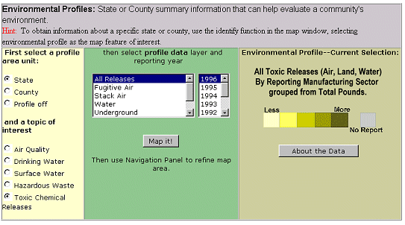
- Select type of area to profile. The beginning view, if you start directly from the complete U.S. map shows state profiles. If you zoom by geography, the environmental profile initial views will vary, depending on the scale of geography chosen. You can override the default by clicking the toggle circle you prefer.
- Select topic of interest. Select the basic type of environmental information desired. The default for new selections is the Toxic Release Inventory.
- Select profile data and reporting year. From the pull-down list, select the specific type of data you want displayed. If desired, select a specific data year. The most recent year available is the default year.
- Environmental profile – Current Selection. This legend is depicted as a color bar ranging from lighter to darker shades. Each graduation of color represents a specific environmental status level, ranging from “less” to “more.” A separate color represents areas for which either data is below reporting threshold or has been reported as zero. Generally, the lighter color over an area, the less the variable (pollutant, etc.) is released. The wording above this legend serves as a map title.
- About the data. This button links to a descriptive report describing the sources, accuracies, uses, and limitations to the profile topic selected.
EnviroMapper opens an environmental profile in a separate browser window from the main EnviroMapper mapping window. Only two total windows can be open at any one time. In order to obtain (or compare) more than one profile, you may:
- Obtain the first profile you want
- To improve performance, close this new window when you are done viewing the profile report
- Query EnviroMapper to obtain the next desired profile
- If you did not close the browser window that contained the first profile report, and subsequent profile reports will be obscured from immediate vision, behind the EnviroMapper browser window. Toggle between browser windows to go between profile reports and EnviroMapper maps
To obtain more information about a specific profile data layer, click the “About the Data” button under Environmental Profile – Current Selection.

Frequently Asked Questions
These questions can be found at: http://www.epa.gov/enviro/html/em/em_faq.html

What is EnviroMapper?
EnviroMapper is a Web-based interactive mapping tool for viewing and querying environmental information. This application allows users to Zoom-In to an area, or enter a state, county, city, ZIP code, or watershed to view environmental data from EPA's Envirofacts Warehouse is displayed.

Why would I use EnviroMapper (i.e., what services or information does it provide)?
EnviroMapper allows you to generate maps of your geographic area that contain environmental information stored in EPA's Envirofacts Warehouse. The type of environmental information includes: Superfund sites, drinking water, toxic and air releases, hazardous waste, and water discharge permits. You can also view this information in context by adding map features to your map, including major roads, railroads, churches, hospitals, schools, populated places, counties, states, streams, streets, water bodies, watersheds, rivers, and federal lands.

How do I use EnviroMapper?
EnviroMapper can be accessed through your Web browser. The first screen displays a map of the United States (including Alaska, Hawaii, Puerto Rico and the Virgin Islands). Use one of the drop-down menus next to the Zoom In option to select the degree to which you would like to zoom in (2X is the default) or a radius, and then click on the map. You can also zoom in by entering a state, county (and state), city (and state), watershed or zip code. More information is available through EnviroMapper's on-line user guide (or this manual!!!).

How do I create a map of my community?
There are two ways to generate a map of the community. One way is to use the Zoom In feature. To do this, select the degree to which you would like to zoom from the drop-down menu or a radius to which you would like to zoom in to from the radius drop-down menu. Next, click the geographic area that you would like to view on the map. Each time you click, you will zoom in further. Your other choice is to zoom in by entering a state, county (and state), city (and state), watershed or zip code.

What are layers?
"Layers" is a term used in the Geographic Information System (GIS) community to refer to how spatial data are stored. Examples of spatial data include: state and county boundaries, roads, railroads, and other points of interest. In EnviroMapper, these data are stored according to the feature, meaning that if you turn on (click on the box) for railroads, it will be displayed on your map.

Can I re-center the map to view a particular area?
You can user the Re-center Map option or the compass. To use the re-center map option, first click on the corresponding radio button (circle), then click on the area of the map that you would like to center on. This will automatically redraw the map and re-center the map at the point you just clicked on. Another option is to use the compass to move the map in a particular direction.

Why can't I see the environmental information?
To be able to generate reports of environmental information, you must zoom in far enough on the map (so the map displays 16 miles across, maximum). This can be accomplished by either zooming in manually, or zoom in by entering a state, county (and state), city (and state), watershed or zip code.

Can I print my map?
EnviroMapper now offers the ability to print the map you are viewing. Maps can be printed through your browser by clicking on the Print Map option. A dialog will pop up to let you enter your map title. The printable map include the legend, scale, and north arrow.

Why did I get a JavaScript error?
JavaScript errors generally occur when the browser you use does not support JavaScript 1.1 used by EnviroMapper. Another suggestion is to make sure that your browser has been configured to enable JavaScript (you can typically find this in the preferences option of your browser menu). If you are running an older browser you may want to download the latest copy of the browser from the Internet to alleviate potential problems. If you are using Microsoft IE Explorer 4.0, please upgrade to version 4.0.1.

Where can I find directions on how to use EnviroMapper?
On-line help is available. From the application screen, click on the On-Line Help option. This manual was designed directly from the on-line help files.

Who do I contact with questions?
Use the Maps on Demand Feedback Form to submit any questions or comments you have about EnviroMapper.

ENVISION Spring Workshop Introductory Lessons
Exercise 1: Find Your Home Town by Zooming In With Menus
- At the first page you see (largest map), uncheck all “Mapping Features” except for states.
- Click the “Redraw Map” button.
- Click the toggle circle for “Zoom-In by:” and choose a value from one of the two pull down menus.
- Click on your home state. Continue zooming in with either of the two choices until you find your town by clicking where it should be on the map repeatedly.
- If you zoom in too far, you can zoom back out using the Radius menu in the “Zoom-Out by:” box. Remember to click on the correct toggle circle.
- You can move the visible map in the cardinal directions by clicking the appropriate point on the compass.
- In the “Mapping Features” box, uncheck all features except for streets, water bodies, and counties.
- Click the “Redraw Map” button.
- You should now see your town with the major roads, water bodies, and possibly counties in the Main Map Screen.
- Click the “Zoom Reset” button above the compass to start over.

Exercise 2: Find Your Home Town by Zooming In by Geography
- At the first page you see (hereafter referred to as the “Start Page”), click the “Zoom In by Geography” link below the map screen.
- Click on the “Zoom in by City” toggle circle, and select your state from the menu. Click the “Zoom to Chosen Geography” button. Select your city from the list. If your city isn’t listed, try the nearest one. Click the “Submit” button.
- When the map is displayed, uncheck all features except for streets, water bodies, and counties, then click the “Redraw Map” button.
- You should now see your town with the major roads, water bodies, and possibly counties in the Main Map Screen.
- Click the “Zoom Reset” button above the compass to start over.

Exercise 3: Selecting Layers to Display
- At the Start Page, elect to Zoom In by Geography.
- Choose to zoom in to a city by clicking on the toggle circle for that choice.
- Choose Indiana and submit, them choose West Lafayette and submit again.
- De-select the checkbox for NPL sites and check the box for Schools.
- Click the “Redraw Map” button. You should now see all schools on this map.
- De-select all checkboxes except for Counties and redraw the map.
- Zoom out by selecting “4X” from the pull down menu , clicking on the toggle circle for “Zoom-out by:”, and clicking on the words “West Lafayette”.
- Select the checkboxes for NPL Sites, Rivers, and Railroads. Also be sure that the State and Counties checkboxes are selected. Redraw the map. As you can see, by choosing different layers, you can examine a wide range of variables. In your spare time, play with these map features to look at how they might be related.
Exercise 4: Using the “Identify” Function
1. At the Start Page, elect to Zoom In by Geography.
- Choose to zoom in to a city by clicking on the toggle circle for that choice.
- Choose Indiana and submit, them choose West Lafayette and submit again.
- De-select the checkbox for NPL sites and check the box for Schools.
- Click the “Redraw Map” button. You should now see all schools on this map.
- On the compass, Click West twice, and Northwest once.
- Check the box for Schools. Redraw the map.
- Click on the toggle circle for “Identify” and the toggle circle for “Schools”.
- Click on the school icon near U.S. 231 at the top of the map.
- EnviroMapper will name the school on the map, and give information about the school under the Main Map Screen. You can see that this is another place to obtain exact latitude and longitude coordinates for use with TerraServer.
- Click on the school icon just north of Cherry Lane. What is it?
- Do you want to identify the street that Klondike School is on? Select the toggle circle for “Identify”, the toggle circle for “Streets”, and click on that road. This is County Road 300 (also known as Klondike Road).
- Zoom out by a factor of 8X.
- The red square north of Lafayette indicates a NPL Site. Zoom in to a radius of 1 mile by selecting the toggle circle for “Zoom-In by:” and selecting “1 mi” from the Radius menu. Click on the NPL site.
- Identify the NPL Site just like we identified schools. What information is given?
- Click on the hyperlink in the information window below the map.
- By clicking on various links in this table, we can learn about the site. Take a few minutes to read some information about the Tippecanoe County Sanitary Landfill.
- To return to EnviroMapper, close the new browser window.
- Start a new map.

Exercise 5: Finding Your Watershed
1. Use the “Zoom in by Geography” link to zoom to your State.
- Select the checkbox for Watersheds, uncheck the box for NPL Sites, and redraw the map.
- The blue areas identify the boundaries of watersheds as defined by the EPA. To identify your watershed, use the identify function as before.
- EnviroMapper will place a grid over your watershed and show its name.
- Zoom in on your watershed, trying to make it as big as possible, but still in your map screen.
- If you need to center your watershed in the map screen, click on the “Recenter Map” toggle circle and then click in the middle of your watershed.
- Uncheck all boxes in Map Features except for Watersheds and States. Select the layer for Rivers. Redraw the map.
- You can now re-identify your watershed to see what the river system looks like within it. If you wish, you can identify rivers using the “Identify” function.
- If you want to see if there are any NPL Sites in your watershed, select that layer in addition to what you already have and redraw the map.

