Environment Survey

Below are several photos (images). For each photo, indicate whether you think the photo is a picture of an environment and explain why you think that it is or is not a photo of an environment.

Photo 1 Is this an environment? _______ Below, explain why this is or is not an environment:
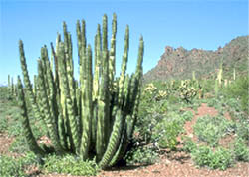
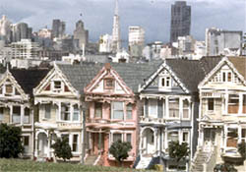
Photo 2 Is this an environment? _______ Below, explain why this is or is not an environment:

Photo 3 Is this an environment? _______ Below, explain why this is or is not an environment:

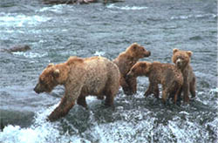

Photo 4 Is this an environment? _______ Below, explain why this is or is not an environment:
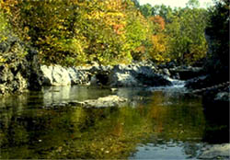

Photo 5 Is this an environment? _______ Below, explain why this is or is not an environment:
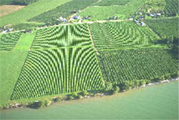

Photo 6 Is this an environment? _______ Below, explain why this is or is not an environment:

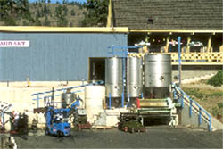

Photo 7 Is this an environment? _______ Below, explain why this is or is not an environment:
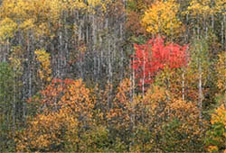
Environment Survey

In the space below draw a picture of what you think an environment is (what it looks like). Label the parts of your drawing. Below your drawing write several sentences that explain why your drawing is an environment, that is what makes it an environment.

Drawing of an environment:

Written explanation of drawing. Why my drawing is an environment:

