
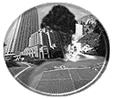

National Atlas:

A Tool for

Investigating the Environment

Lead Staff Member | Time Allotment
Dan Shepardson | 2 hours

Overview

National Atlas of the United States is a USGS developed GIS-based web site designed for educational use. The web site allows learners to investigate natural, human built, and sociocultural landscapes by creating maps and map layers showing relationships between environmental data and information (parameters). Through this process, learners are able to generate questions and investigate the environment and construct knowledge about the relationships between environmental parameters.

Instructional Cluster
- Sense of Purpose |  Eliciting Ideas |  Engaging Learners
The goals for this activity are (1) learn about and explore National Atlas and (2) use National Atlas to answer an environmental question and design a classroom-based lesson. |  | Learners first review and describe how to use the National Atlas. Next they conduct an environmental investigation by generating a question to be answered through the use of the National Atlas.
- Developing and Using  Scientific Ideas | - Reflecting on Ideas and Experiences |  Assessing Progress
Based on the environmental question, learners construct map layers displaying the relationship between environmental parameters and draw conclusions to answer their question. | Teams share their question, investigation, results, and interpretations. Teams also share their progress in designing a classroom-based activity.

Objectives  Learn how to use the National Atlas and design an instructional approach for incorporating National Atlas into the classroom.  ➢ Generate an environmental question to be answered through using the National Atlas, learning about the relationships between environmental parameters. | Materials
 | AAAS design clusters
 | Safety Issues/Precautions

Procedure

- Overview the two purposes for the activity: (1) learning about and exploring National Atlas and (2) using National Atlas to answer an environmental question and design a classroom-based lesson.

- Introduce the National Atlas web site (http://www.nationalatlas.gov/). Have learners click on the “About the Atlas” button and review the screen describing how to use the National Atlas. Questions to focus the activity:

- What are the three frames on the screen? (Map display, Query and Layers, and Index map)
- How do you build a map showing relationships between environmental parameters? (Click on the parameters of interest in the Query/Layers frame)
- How do you draw or construct a map? (Click on the Redraw button in the Map Display frame)
- How do you display the legend? (Click on the Legends button in the Map Display frame)

Note: Maps may be printed or saved as images by right clicking on the mouse. Saved images may then be used in written reports or on overheads and web pages.

- Next have learners conduct a mini-environmental investigation. In this activity, each team is to generate a question to be answered through the use of the National Atlas. To conduct the mini-environmental activity (see Appendix for example):

- Have learners click on the “Atlas Maps” button to enter the active window. Remind learners it takes several seconds for the program to load all three frames.
- Next point out the different environmental parameters (Query/Layer frame) that learners have available to work with. The questions they generate must be answerable based on the environmental parameters available.
- Have each team generate at least five possible questions to answer and then select one question to investigate. The questions should reflect closely an activity that they could use in their classroom. Caution learners that some map layers may obscure other map layers making their combined map meaningless. In these cases individual maps should be printed and compared. This may be accomplished by printing maps on overhead transparencies and then layering the maps. Show examples of map layers (see Appendix).
- Each team has about 30 min. to complete their mini-environmental investigation. Inform the teams that you will call on 3-4 teams to share their investigation, results, and interpretations. If time is available allow other teams to share.

- Next learners craft an environmental investigation lesson using National Atlas and the design clusters. In the remaining time each team is to design a lesson for use in their classroom that uses the National Atlas as either a computer-based activity or as a resource for developing instructional materials. The classroom activity is to be designed around the AAAS instructional clusters: sense of purpose, eliciting ideas, engaging learners, developing and using scientific ideas, reflecting on ideas and experiences, and assessing progress. The teams do not have to complete their activity, as they will have additional days during the summer to work on their instructional programs.

- Have 3-4 teams share their progress in designing their activity.

National Research Council Science Education Standards

Professional Development
Professional Development Standard A Professional development for teachers of science requires learning essential science content through the perspectives and methods of inquiry.
- Address issues, events, problems, or topics significant in science and of interest to participants.
- Introduce teachers to scientific literature, media, and technological resources that expand their science knowledge and their ability to access further knowledge.
Professional Development Standard B Professional development for teachers of science requires integrating knowledge of science, learning, pedagogy, and students; it also requires applying that knowledge to science teaching.
- Address teachers’ needs as learners and build on their current knowledge of science content, teaching, and learning.
- Use inquiry, reflection, interpretation of research, modeling, and guided practice to build understanding and skill in science teaching.
Professional Development Standard C Professional development for teachers of science requires building understanding and ability for lifelong learning.
- Provide regular, frequent opportunities for individual and collegial examination and reflection on classroom and institutional practice.
Professional Development Standard D Professional development programs for teachers of science must be coherent and integrated.
- Clear, shared goals based on a vision of science learning, teaching, and teacher development congruent with the National Science Education Standards.

Teaching
Teaching Standard E Teachers of science develop communities of science learners that reflect the intellectual rigor of scientific inquiry and the attitudes and social values conducive to science learning.
- Display and demand respect for the diverse ideas, skills, and experiences of all students.
- Nurture collaboration among students.

Inquiry
Identify questions that can be answered through scientific investigations.
Use appropriate tools and techniques to gather, analyze, and interpret data.
Develop descriptions, explanations, predictions, and models using evidence.
Think critically and logically to make the relationships between evidence and explanations.
Recognize and analyze alternative explanations and predictions.
Communicate scientific procedures and explanations.

Content
Science in Personal and Social Perspective
Populations, resources, and environments.
Natural hazards.
Science and technology in society.

References
USGS (2000). National Atlas of the United States (http://www.nationalatlas.gov/).
Resources
AAAS Design Clusters

Appendix:
Example of National Atlas Maps Comparing Land Use and Population Density to Hazardous Waste Handlers at Different Levels of Scale

Relationship between land cover characteristics and hazardous waste handlers within West Lafayette and Lafayette Indiana.

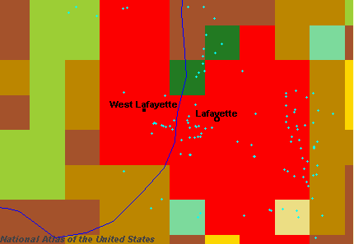

Relationship between land cover characteristics and hazardous waste handlers within the Tippecanoe County area.

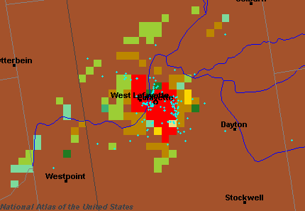
Relationship between land cover characteristics and hazardous waste handlers within Central Indiana.
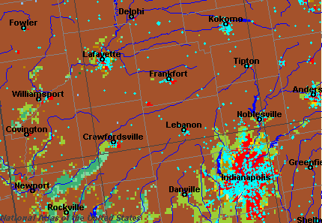

Legend:

Blue dots = Hazardous Waste Handler
Red = Urban Areas
Brown = Cropland
Light Green = Mixed Grass and Cropland
Dark Green = Deciduous Forest

