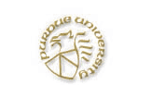
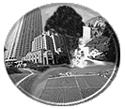

Designing

Alternative and

Standards-based Assessments

Lead Staff Member | Time Allotment
Dan Shepardson | 2 hours

Overview
Engages learners in thinking about and reflecting on their classroom assessment practice and designing alternative and standard-based assessments.

Instructional Cluster
- Sense of Purpose |  Eliciting Ideas |  Engaging Learners
Introduces participants to analyzing and designing alternative assessment tasks. | Participants define/describe testing, assessment, evaluation, and grading and reflect on their current assessment practice. | Participants analyze sample practical and open-response tasks on drinking water and develop a scoring rubric for assessing student performance.
- Developing and Using  Scientific Ideas | - Reflecting on Ideas and Experiences |  Assessing Progress  Assessment tasks developed by participants may be evaluated for understanding assessment task design.
Each group completes the “Assessment Task and Scoring Rubric Planning Template” for one task. Using the “Assessment Evaluation Matrix” based on the NRC standards, participants evaluate sample assessment tasks. | Participants share their designed assessment tasks and assessment task evaluations.

Objectives  Engage learners in thinking and reflecting on their current classroom assessment practice.  ➢ Involve learners in analyzing and designing alternative assessment tasks, specifically open-response and practical tasks. | Materials

Sample assessment tasks.
➢ Copies of the assessment planning template and analysis matrix (see Appendix).

Safety Issues/Precautions

Procedure
1. Ask participants to define/describe, one word at a time, what testing, assessment, evaluation, and grading mean to them. Share and discuss the overhead describing the difference between testing, assessment, evaluation, and grading (Appendix).

2. Have participants complete the “Matrix of Classroom Assessment Practice” (Appendix) as a means for reflecting on their current assessment practice. Ask for volunteers to share their evaluation and discuss the pros and cons to their assessment practice. The left column reflects a more traditional assessment approach, where the right column reflects a more alternative assessment approach.

3. Distribute copies of the sample practical and open-response tasks on drinking water (Appendix). Have participants characterize the tasks:

- What makes the practical task different from the open-response task?
- How do the 2 practical tasks compare?
- How do the 2 open-response tasks compare?

- Have each group complete the “Assessment Task and Scoring Rubric Planning Template” for one of the drinking water task (Appendix). Based on the completed planning template have participants generate a scoring rubric (analytical and holistic—performance levels) for the task. Remind participants that in planning their own assessments that the first step is identifying the student performances to be assessed, followed by developing the task and prompt to reflect the performances to be assessed, then stating how the performances are demonstrated by completing the task, and then develop the scoring rubric. Have participants share their scoring rubric.

5. Using the “Assessment Evaluation Matrix” (Appendix) based on the NRC standards, participants evaluate sample assessment tasks and share their evaluation with the group. Distribute one assessment task from Doran, Chan, and Tamir (1999) to each group to evaluate and share with the group.

National Research Council Science Education Standards

Professional Development
Professional Development Standard B Professional development for teachers of science requires integrating knowledge of science, learning, pedagogy, and students; it also requires applying that knowledge to science teaching.
- Address teachers’ needs as learners and build on their current knowledge of science content, teaching, and learning.
- Use inquiry, reflection, interpretation of research, modeling, and guided practice to build understanding and skill in science teaching.
Professional Development Standard C Professional development for teachers of science requires building understanding and ability for lifelong learning.
- Provide regular, frequent opportunities for individual and collegial examination and reflection on classroom and institutional practice.
Professional Development Standard D Professional development programs for teachers of science must be coherent and integrated.
- Clear, shared goals based on a vision of science learning, teaching, and teacher development congruent with the National Science Education Standards.

Teaching
Teaching Standard A Teachers of science plan an inquiry-based science program for their students.
- Select teaching and assessment strategies that support the development of student understanding and nurture a community of science learners.
- Work together as colleagues within and across disciplines and grade levels.
Teaching Standard C Teachers of science engage in ongoing assessment of their teaching and of student learning.
- Use multiple methods and systematically gather data about student understanding and ability.

Assessment
Assessment Standard A Assessments must be consistent with the decisions they are designed to inform.
- Assessments are deliberately designed.
- Assessments have explicitly stated purposes.
Assessment Standard B Achievement and opportunity to learn science must be assessed.
- Achievement data collected focus on the science content that is most important for students to learn.
- Equal attention must be given to the assessment of opportunity to learn and to the assessment of student achievement.
Assessment Standard C The technical quality of the data collected is well matched to the decisions and actions taken on the basis of their interpretation.
- The feature that is claimed to be measured is actually measured.
- Assessment tasks are authentic.
- Students have adequate opportunity to demonstrate their achievement.
Assessment Standards D Assessment practices must be fair.
- Assessment tasks must be reviewed for the use of stereotypes, for assumptions that reflect the perspectives or experiences of a particular group, for language that might be offensive to a particular group, and for other features that might distract students from the intended task.

References

Doran, R, Chan, F., & Tamir, P. (1999). Science Educators Guide to Assessment. Arlington, VI: National Science Teachers Association.

Gummer, E and Shepardson, D.P. (in press). The NRC Standards as a Tool in the Professional Development of Science Teachers Assessment Knowledge and Practice. In D.P. Shepardson (Ed.), Assessment in Science: A Guide to Professional Development and Classroom Practice. Dordrecht, Netherlands: Kluer Academic Publishers.

Shepardson, D.P. (in press). A professional development framework for
collaborating with teachers on changing classroom assessment practice. In D. P. Shepardson (Ed.), Assessment in Science: A Guide to Professional Development and Classroom Practice. Dordrecht, Netherlands: Kluer Academic Publishers.

Appendix:
Definition of Assessment and Evaluation

Testing

A one-dimensional measurement of student performance, often achievement based and multiple choice with a single test score as evidence.

Assessment

The multi-dimensional measurement of student performance, utilizing multisource techniques as indicators and sources of evidence.

Evaluation

The interpretation of assessment data leading to the judgement of student performance or progress based on guidelines and criteria.

Grading

The assignment of a letter, numerical score, or percentage that reflects student performance.
Matrix of Classroom Assessment Practice*

 | Always | Mostly | Balanced | Mostly | Always
On Demand |  |  |  |  |  | Ongoing
Individual |  |  |  |  |  | Group
Unassisted |  |  |  |  |  | Assisted
Written |  |  |  |  |  | Oral
Closed-ended |  |  |  |  |  | Open-ended
Rote/Memorization |  |  |  |  |  | Authentic
Factual-based |  |  |  |  |  | Performance  -based
Product Driven |  |  |  |  |  | Process and Product
Single Discipline |  |  |  |  |  | Interdisciplinary
Single Trait |  |  |  |  |  | Multitrait
At end of unit |  |  |  |  |  | Throughout  unit
Summative |  |  |  |  |  | Diagnostic
Answer only |  |  |  |  |  | Reasoning processes

Assessment Formats:

Quizzes

Tests/Examinations
Laboratory Practicals
Laboratory Write ups
Extended Projects
Oral Presentations
Draw and Explain
Extended Writing
Concept Maps/Graphic Organizers
Others (please list):

Other Questions about Classroom Assessment Practice:

*From Shepardson, D.P. (in press). A professional development framework for
collaborating with teachers on changing classroom assessment practice. In D. P. Shepardson (Ed.), Assessment in Science: A Guide to Professional Development and Classroom Practice. Dordrecht, Netherlands: Kluer Academic Publishers.
Assessment Task and Scoring Rubric Planning Template*

Description of performances to be assessed in the assessment task  (Based on the NRC Standards) | Description of how performances are to be demonstrated in the assessment task
Conceptual understanding:

Content or factual knowledge:

Thinking/reasoning processes:

Science processes/Inquiry skills:

The task:

The prompt:

Scoring Rubric:

*From Shepardson, D.P. (in press). A professional development framework for
collaborating with teachers on changing classroom assessment practice. In D. P. Shepardson (Ed.), Assessment in Science: A Guide to Professional Development and Classroom Practice. Dordrecht, Netherlands: Kluer Academic Publishers.

Assessment Evaluation Matrix

Based on the NRC Assessment Standards*

Purpose

E S NS
Is the purpose of the assessment clearly articulated?
Does the assessment provide useful information to the shareholders?
Is the assessment a part of a repertoire of a wide range of performances

Validity

Is there a match between the purpose of the assessment and the process used?
Does the assessment measure valued outcomes?
Key themes or concepts
Cognitive skills
Does the assessment provide an opportunity for the student to communicate what he/she knows?
Does the assessment provide information for logical and sound inferences?
Is the written plan for the assessment purposefully designed?

Learning Tool

Is the assessment an ongoing process?
Is the assessment developmentally appropriate for the students with whom it will be used?
Is there an opportunity for students to engage in
Self assessment
Peer assessment

Authenticity

Does the assessment reflect science as scientists do science?
Does the assessment reflect the real world?
Does the assessment engage students’ interests?
Does the assessment require the student to demonstrate knowledge to make personal and societal decisions?
Is the assessment inquiry-based?

Equity

Is the assessment equitable?
Is there evidence that the students have had the opportunity to learn the content and skills covered by the assessment?

Technical Aspects

Does the assessment task have a clearly written prompt?
Are the criteria for scoring the assessment provided with the task?
Are the scoring criteria appropriate for the task?
Do the scoring criteria define a wide range of performances?

E: Exceptional
S: Satisfactory
NS: Not Shown

*From Gummer, E and Shepardson, D.P. (in press). The NRC Standards as a Tool in the Professional Development of Science Teachers Assessment Knowledge and Practice. In D.P. Shepardson (Ed.), Assessment in Science: A Guide to Professional Development and Classroom Practice. Dordrecht, Netherlands: Kluer Academic Publishers.
Example Assessment Tasks for

Drinking Water Quality

Assessment Task 1 (Open Response Task)

Tom, Joe and Mary, students in Ms. Well’s classroom, were discussing the results of their drinking water tests. Their water sample was taken from the well on Mary’s parent’s farm. All of the tests were within the acceptable EPA range except for Nitrate. The Nitrate reading was 12 PPM. The EPA recommends that Nitrate levels be less than 10 PPM. The well is located 150 feet from the septic system, 200 feet from the cornfield, 100 feet from the county road, and 200 feet from the hog feed lot. In determining the cause of the high Nitrate level, Mary believes it is because the well is close to the cornfield and Nitrate from the fertilizer is leaching into the groundwater that flows into the well. Although Tom respects Mary’s idea, he disagrees. Tom thinks that the source of the Nitrate is the hog feed lot. Waste products from the hogs are percolating through the ground after a rainstorm and into the groundwater that flows into the well. Joe, however, thinks the high Nitrate is caused by the road salt used in the winter that runs off the road and leaches into the groundwater that flows into the well. Which student, Tom, Joe, or Mary, do you think has the better explanation for the cause of the high Nitrate level and why?

Assessment Task 2 (Practical Task)

You are the lab technician for the Department of Water Quality for the State. You have received three water samples, one from each of the three wells for the City of Water Valley. The Engineer for Water Valley would like you to test each sample for Total Hardness (total amount of calcium and magnesium dissolved in the water). The Engineer wants to make sure that the water in each well is within the EPA range of 50 to 125 PPM. It is known that soft water (Total Hardness < 50 PPM) can damage copper plumbing and the lead solder used in the joints. Hard water (Total Hardness > 250 PPM) can also damage plumbing by forming scale inside pipes. Hard water also forms scale on the surface of sinks and tubs and reduces the formation of suds from soap. As the technician, you need to test the three water samples (Well 1, Well 2, and Well 3) and write a brief report stating your findings and recommendation to the Water Valley Engineer.

Assessment Task 3 (Practical Task)

You work in the home appliance department of the local department store. Mrs. Johnson has brought in a water sample to test for Total Hardness (total amount of calcium and magnesium dissolved in the water) and Iron to see if she needs to purchase a water softener. You know that the EPA range for Total Hardness is between 50 and 125 PPM. You also known that soft water (Total Hardness < 50 PPM) can damage copper plumbing and the lead solder used in the joints, and that hard water (Total Hardness > 250 PPM) can damage plumbing by forming scale inside pipes. Hard water also forms scale on the surface of sinks and tubs and reduces the formation of suds from soap, making cleaning more difficult. High Iron concentrations (> 0.3 PPM) although causes no health risk, does create an unpleasant taste and can stain laundry, sinks, and tubs. As the clerk, you need to test Mrs. Johnson’s water sample and complete the Customer Report below, recommending whether she needs to purchase the $500 water softener.

Customer Report

Customer Name: _____________________________ Date: __________

Water Test | Results | Recommendation

Clerk Name: ______________________________________

Assessment Task 4 (Open Response Task)

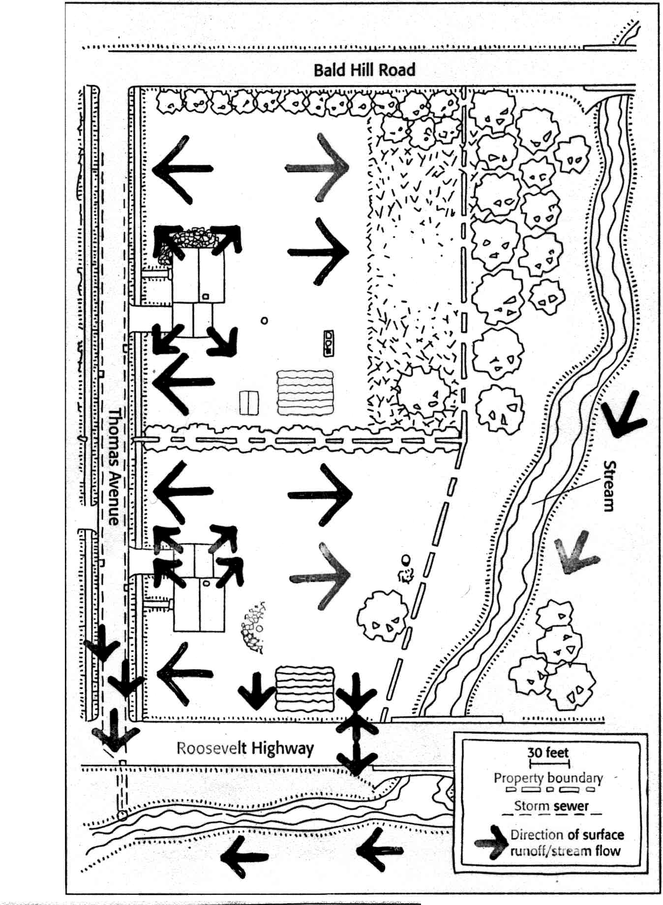
You are the Water Quality Engineer for Water Valley and the two new homes on Thomas Avenue have asked you to recommend the best location on their property to drill their water wells. The location should reduce the risk of well water contamination from storm runoff. You have conducted a site visit identifying the direction of possible water runoff from storms (arrows on site map). Indicate on the map the site you would recommend that each landowner drill their well. You also need to provide a written report that explains the reasons behind your recommendation.

From Home*A*Syst, D.J. Eagan (1997), Editor

